SENIOR SIX TERM 1
TOPIC 1/1: Coordination:
Competency: The learner assesses the physiological and behavioural processes during organisms’ responses to internal and external stimuli, in order to appreciate the adaptive behaviour of organisms and, therefore, promote their welfare to ensure survival and reproductive success.
Contents
Coordination 6
Coordination in plants 6
Tropisms 6
Phototropism 6
Applications of phototropism and Geotropism in agriculture 7
Applications of phototropism 7
Applications of geotropism in agriculture 8
Taxes/tactic responses 8
Types of tactic responses 8
Significance of tactic response 9
Nastic responses 9
Examples of Nastic Responses: 9
Significance of nastic movements 9
Kinesis 10
Plant hormones 10
Experiment to show that growth towards light is controlled by tips of grass coleoptile 11
Role of auxins in plants 11
Commercial application of auxins 11
Gibberellins 12
Commercial application of Gibberellins 12
Cytokinins 13
Commercial application of cytokinins 13
Abscisic acid (ABA) 13
Commercial application of abscisic acid 14
Ethene 14
Commercial application of ethene 14
Phytochrome and effects of light on plant development 15
How Phytochromes Work 15
Effects phytochromes on Plant Development 15
The significance of photoperiod in plants 16
Vernalization and flowering 16
Coordination and control in animals 17
Differences between effector and sensory neurons 17
Structure of the nerve cell 18
Transmission of impulse 18
The impulse 18
Properties of nerves and impulses 19
Factors that affect nerve conduction velocity 19
The Synapse 20
Structure of the chemical synapse 20
Transmission across a synapse 20
The transmitter substances 21
Differences between inhibitory and excitatory synapses 21
How is the transmission across the synapse controlled? 21
Significance of warm-ups before physical activity in relation to transmission of impulses 22
Significance of the use of cold packs in first aid 22
The role of local anaesthetics 22
The action of drugs and poisons 22
Function of synapse 23
The vertebrate nervous system 24
Reflex action and reflex arch 24
Conditioned reflex arch 24
The autonomic nervous system 24
The brain 25
Function of the main parts of the brain the human brain 26
Hormonal communication 26
How hormones control cells 28
Receptors cells 29
Mechanism of receptor cells 29
Properties of receptors 29
Mechanisms Ensuring Receptor Efficiency 30
The eye 30
Functions of the parts of the eye 30
Controlling amount of light entering the eye 31
Accommodation 31
The retina 31
Differences between rods and cones 32
The significance of the distribution of photoreceptor cells in the eye 33
Mutual or Lateral inhibition 33
Importance of mutual or lateral inhibition 33
Transduction of light in rods 33
Light Transduction in Cones 33
Sensitivity of the retina 34
Retinal convergence 34
Precision of the eye 34
Color vision 34
Adaptation of rod cells 34
Adaptations of cones 35
Reasons for high sensitivity of Rods to light 35
Reasons for high visual acuity of cones 35
Compound eye 35
Comparison of compound and human eyes 37
Eye defects 37
The human Ear 39
The cochlea 40
How Hearing occurs 41
The analysis of sound frequencies by the basilar membrane 41
The vestibular apparatus 43
The utricle and saccule 44
Animal behaviors 45
Instincts 45
Reflex 45
Ecological importance reflex behavior 46
Kinesis 46
Difference between kinesis and taxis 46
Example of kinesis 46
Ecological importance of kinesis 46
Taxis 47
Examples of taxis 47
Ecological importance of taxis 47
Sign of stimuli 47
Learning 47
Types of learning 48
Habituation 48
Examples of habituation 48
Importance of habituation 48
Associative learning or conditioning 48
Classical conditioning 48
Examples of classical conditioning 48
2. Little Albert Experiment 49
3. Taste Aversion 49
4. School Bell and Student Behavior 49
5. Dog Leash and Excitement 49
Operant conditioning, Instrumental or trial and error learning 49
Examples of operant conditioning 49
Latent learning 50
For examples of latent learning/observational learning 50
Importance of latent learning 50
Insight learning 51
Imprinting 51
Importance of imprinting behavior 51
Displacement activity 51
Examples of displacement activity 52
Importance of displacement activity 52
Reproductive behavior 52
Choosing a mate 52
Species-specific signals 53
Functions of courtship 53
Communication 53
Importance of communication in animals 54
Territorial behavior 54
Function of a territory 54
Disadvantage of territory 54
Role of pheromones in territorial behavior 55
Role of testosterone hormone in territoriality 55
Social behavior 55
Advantages of social behavior 55
Disadvantages of group/social behaviours 56
Altruism and kin selection 56
Migration 56
Advantages of migration 57
Disadvantages of migration 57
Revision exercise on plant response 59
Revision exercise on coordination in animals 74
Revision questions on receptors, eyes and ears 95
Mechanisms Ensuring Receptor Efficiency 106
Revision exercise on behaviors in biology 110

Coordination
Coordination means to cause the part to function together or in proper order.

Coordination in plants
Coordination is a process of linking up process in the body of an organism such that the various process occurs in organized manner.

Plants responses to the environment are controlled by chemicals or hormones. Responses in plants occur in different ways including
- Tropisms
- Tactic movements
- Nastic responses
- Flowering responding to day length

Tropisms
Tropic movements are growth responses towards directional stimuli.
Types of tropisms
Tropisms are classified based on type of stimulant.
- Phototropism (light)
- Hydrotropism (water)
- Geotropism (gravity)
- Thigmotropism (touch)
- Chemotropism (chemical)

Phototropism
It is a growth response towards light from one direction. Shoots grow towards unidirectional light and are said to be positively phototropic. Most roots do not respond to light.
Experiment to demonstrate effect of unidirectional light on the growth of shoot
- Select two potted seedlings of bean of equal age and size and water them.
- Place one of the seedlings in a box painted black on each side. The box should have a hole on one side to allow in light.
- Subject the second seedling to the same conditions as the first one except that the pot is mounted on a slowly rotating clinostat.
- Leave the experiment to stand for 3 days
Note that each seedling should be growing straight at the beginning of the experiment.

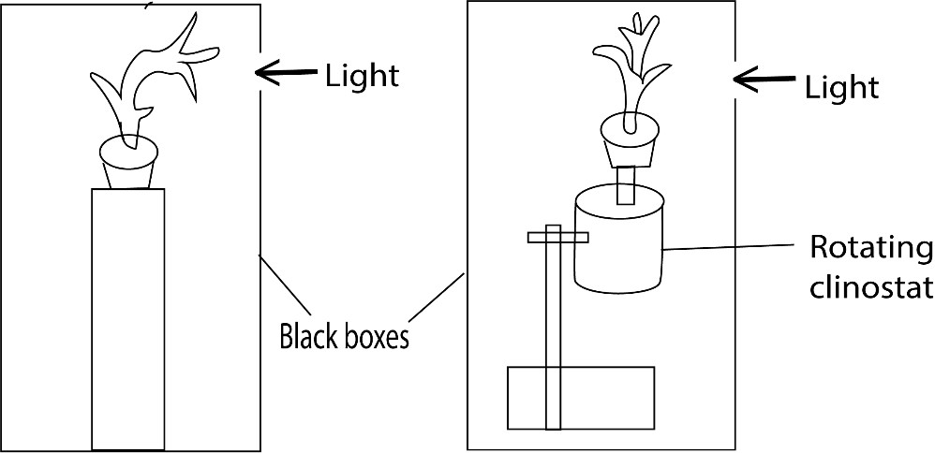

Observation
The seedlings on the clinostat grew straight while the other bent toward light
NB. Slowly rotating clinostat ensures uniform exposure of the shoot from all direction.
The significance of phototropism, allow shoot to grow towards and receive light for photosynthesis.
Importance of phototropism
Positive phototropism causes the stems of plants to grow towards a light source causing the leaves of the plant to be pointing towards the light source; this allows the leaves to absorb more light which maximizes photosynthesis.

Applications of phototropism and Geotropism in agriculture
Both phototropism (growth response to light) and geotropism (growth response to gravity) are fundamental plant behaviors with significant applications in agriculture, enabling farmers and botanists to optimize crop growth, increase yields, and utilize limited space efficiently.

Applications of phototropism
- Optimizing plant growth in greenhouses and controlled environments: Indoor or controlled agriculture, such as vertical farms and greenhouses, phototropism is actively managed to ensure plants receive adequate and uniform light by strategically positioning LED light to produce even light distribution.
- Enhanced productivity: By controlling the direction, intensity, and duration of light exposure, growers can guide a plant's growth pattern to maximize light absorption for photosynthesis, boosting overall yield.
- Maximizing space: In vertical farming, LED lights allow growers to exploit vertical space. The strong phototropic response of plants, which tends to override geotropism, ensures that plants grow towards the lights in a predictable manner, no matter their orientation.
- Harnessing heliotropism: Some plants, like sunflowers, exhibit heliotropism, where their flowers track the sun's movement. This behavior is naturally exploited to ensure the plant's reproductive organs receive maximum light.

Applications of geotropism in agriculture
- Seed germination and plant growth: Farmers can broadcast seeds without worrying about their orientation, as geotropism will naturally direct the roots toward the soil and the shoots toward the surface. Growth of roots downward provides anchorage and enable absorption of water and nutrients from the soil.

- Manipulating growth for ornamental or special crops: In some agricultural contexts, geotropism is manipulated to alter a plant's growth habit for specialized purposes. For instance, by growing crops like peppers or tomatoes in hanging baskets, the shoot's negative geotropism causes it to grow upward, leading to an aesthetic and unique cultivation method.

Taxes/tactic responses
They are movements of an entire cell or organism (i.e. locomotion) in response to, and directed by an external stimulus. Tactic responses can be described as positive or negative, and can be further classified according to the nature of stimulus

Types of tactic responses
There are many types of tactic movements including
- Phototaxis (stimulation by light)
- aerotaxis (stimulation by oxygen)
- anemotaxis (by wind)
- barotaxis (by pressure)
- chemotaxis (by chemicals)
- durotaxis (by stiffness)
- electrotaxis or galvanotaxis (by electric current)
- gravitaxis (by gravity)
- hydrotaxis (by moisture)

Significance of tactic response
Tactic responses are crucial for the survival and adaptation of motile organisms like bacteria, protists, and some invertebrates, allowing them to move towards favorable stimuli (nutrients, light) and away from harmful ones (toxins, predators), thereby optimizing growth, reproduction, and defense. These directed movements facilitate critical processes like photosynthesis, nutrient acquisition, escaping danger, and colonizing new environments.

Nastic responses
They are a non-directional movement of part of a plant is response to an external stimulus. Examples of nastic movements

Examples of Nastic Responses:
- Nyctinasty: "Sleep" movements where leaves fold at night and open in the day (e.g., prayer plants).
- Thigmonasty: Movement in response to touch (e.g., Mimosa pudica leaflets folding).
- Photonasty: Opening or closing of flowers or leaves in response to light (e.g., evening primrose opening at dusk, morning glory close flower at night, ground nuts close their leaves in the dark ).
- Seismonasty: A rapid, shock-induced movement, similar to thigmonasty.
- Venus Flytrap Closing: A fast thigmonastic response to prey.

Significance of nastic movements
- Herbivore Deterrence: The sudden folding of leaves, as seen in the Mimosa pudica (sensitive plant), can startle or deter herbivores.
- Predator Trapping: Nastic movements are crucial for insectivorous plants like the Venus flytrap, which snap shut to capture prey when triggered.
- Water Conservation: Closing leaves at night (nyctinasty) or in response to touch
(thigmonasty) can reduce water loss through transpiration, especially on hot, dry days.
- Light Management: Adjusting leaf orientation (photonasty) maximizes sunlight capture during the day and minimizes exposure during harsh light or intense heat, aiding photosynthesis.
- Temperature Regulation: Folding leaves can also help reduce exposure to cold or overly hot conditions.

Kinesis
This is a type of locomotory response. Since this is virtually confined to the animal kingdom it will be discussed with animal behavior plant growth substances.

Plant hormones
There are chemicals substances that control co-ordination in plant growth

Auxins
Auxin, any of a group of plant hormone that regulate or modify growth of plants, especially root formation, bud growth, and fruit and leaf drop. They include indole acetic acid (IAA)
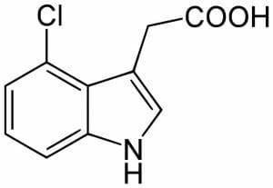
Auxins are produced at the shoot and root tips and concentrates on the side opposite the stimuli. In stem high concentration of auxins stimulates growth while high concentration of auxins in roots inhibits growth as shown in the graph below
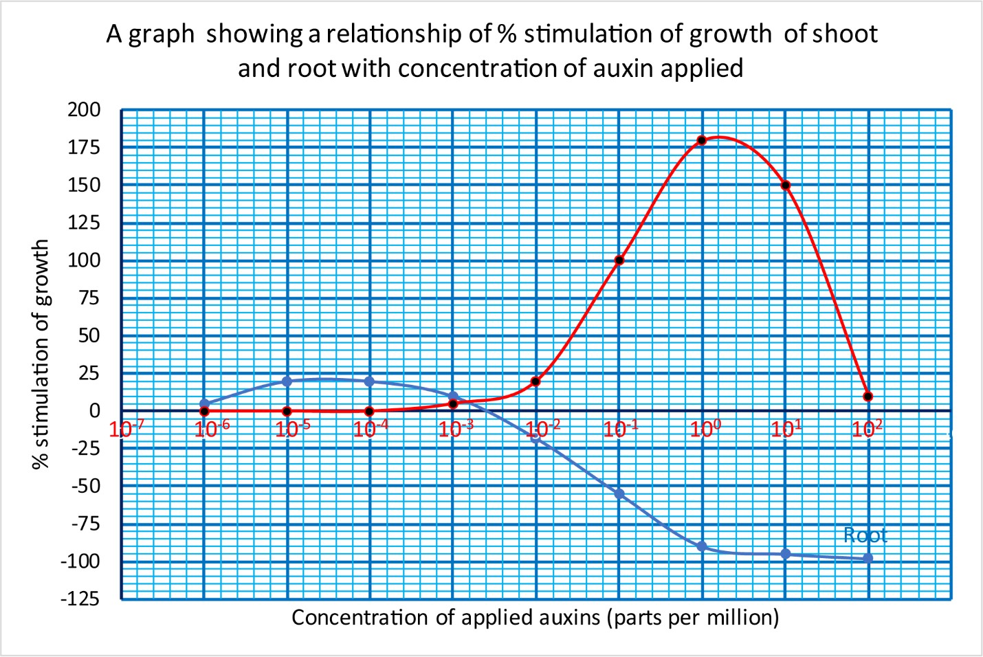

Experiment to show that growth towards light is controlled by tips of grass coleoptile
Charles Darwin and his son Francis carried out the following experiments showed that growth toward light is controlled by tips of grass coleoptiles.
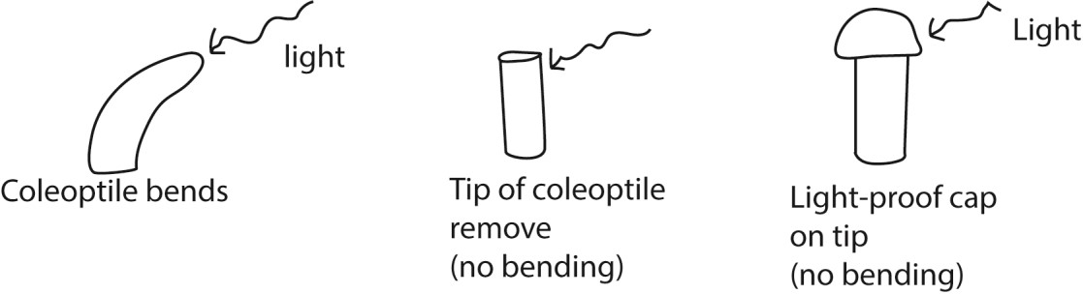
It was latter shown that the tip of grass coleoptile control growth by production of auxins in presence of light

Role of auxins in plants
- Stimulates cell elongation
- Stimulates cell division in the cambium and, in combination with cytokinins in tissue culture
- Stimulates differentiation of phloem and xylem
- Stimulates root initiation on stem cuttings and lateral root development in tissue culture
- Mediates the tropic response of bending in response to gravity and light
- The auxin supply from the apical bud suppresses growth of lateral buds (vii) Delays leaf senescence
- Can inhibit or promote (via ethylene stimulation) leaf and fruit abscission
- Delays fruit ripening
- Promotes flowering in Bromeliads
- Promotes (via ethylene production) femaleness in dioecious flowers
- Stimulates the production of ethylene at high concentrations

Commercial application of auxins
- Root development: Auxins, particularly synthetic forms like Indole-3- butyric acid (IBM)and Naphthaleneacetic acid (NAA), are commonly used in rooting powders to stimulate root formation in plant cuttings for vegetative propagation. This enables horticulturists to produce genetically identical plants efficiently.
- Fruit development: Auxins are used to produce seedless fruits such as in grapes and oranges.
- Weed control: Synthetic auxins like 2,4-Dichlorophenoxyacetic acid (2,4-D) are effective herbicides that selectively target broadleaf weeds while sparing grasses. This selective action allows for effective weed management in crops like corn and wheat, reducing competition and improving yields.
- Lodging Prevention: In crops prone to lodging (falling over), auxins can strengthen stems by promoting cell division in the cambium, leading to thicker and sturdier stem s. This application is particularly beneficial in cereal crops, where lodging can significantly impact yield.
- Micropropagation: Auxins are essential in tissue culture techniques for massproducing plants. They help in the formation of roots and shoots from small tissue samples, ensuring consistency and quality in crop production.
- Post- harvest management: Auxins are used to delay fruit ripening and senescence extending shelf-life of produce This application is valuable in reducing postharvest losses and maintaining quality during storage and transport.
- Inhibiting potato sprouting: The methyl ester of Naphthaleneacetic acid can be used to inhibit the sprouting of potatoes during storage, extending their shelf life.
- Controlling plant shape: Manipulating auxin levels can be used to control the shape of ornamental plants. Removing the apical bud, which is the source of auxin, eliminates apical dominance and encourages the growth of side shoots to create bushier plants and hedges.

Gibberellins
This is another class of growth promoters produced particularly in young epical leaves (possibly in chloroplasts), buds, seeds and root tips. They fall in group of chemical compound called terpenes.
Role of gibberellins in plants
- Promotes stem and root elongation thus, genetically dwarf varieties of peas and maize are restored to normal growth and dwarf beans can be converted into runners by application of gibberellins.
- Mobilize enzymes that release nutrient reserves in grass seeds.
- they stimulate the growth of side branches from axillary buds
- they break dormancy and promotes germination of seeds
- promotes bolting and flowering in long day plants
- promotes development of seedless fruits (parthenocarpy) (vii) delays senescence

Commercial application of Gibberellins
- Malting of Barley: Gibberellins stimulate the production of α-amylase in germinating barley. This enzyme breaks down starches, aiding in malt production for the brewing industry.
- Increasing Sugarcane Yield: Gibberellins promote internode elongation in sugarcane.This leads to increased growth and higher sucrose accumulation, boosting overall yield.
- Fruit Production: Used to produce seedless and larger fruits, especially grapes.Gibberellins enhance fruit size and improve stalk strength, facilitating better handling and market appeal.
- Seed Production: Applied to stimulate flowering and seed development in crops.

- Horticultural Practices: GAs can stimulate bud break in cut flowers to produce more flowering shoots.
- In some biennial vegetables such as beet and cabbage, gibberellin treatment stimulates bolting and thus time for seed production can be considerably reduced

Cytokinins
This is a class of growth substances that promote cell division. They do so, however in the presence of auxins. Gibberellins may also play a role, as in the cambium.
Roles of cytokinins
- Promotes cell division
- Promotes morphogenesis
- Promotes development of lateral roots
- Delays senescence
- Promotes stomata opening

Commercial application of cytokinins
- Promoting Cell Division and Growth: Widely used in plant tissue culture to promote shoot proliferation and regeneration of plantlets.
- Breaking Seed Dormancy:Applied to seeds to break dormancy and enhance germination, especially in crops with slow or uneven germination rates.
- Delaying Leaf Senescence: Helps extend the shelf life of leafy vegetables and cut flowers.
- Enhancing Flower and Fruit Development: Applied to crops like tomatoes and cucumbers to increase fruit yield and quality.
- Promoting Lateral Bud Growth: Useful in ornamental plants and bonsai cultivation.
- Plant Defense: They can also contribute to increased resistance against diseases and environmental stresses like drought, helping plants to thrive even in challenging conditions.

Abscisic acid (ABA)
Abscisic acid is a major inhibitor in plants and is antagonistic to all the three classes of growth promoters.
Role of abscisic acid
- Maintains leaf dormancy
- Causes stomata closure
- Causes seed dormancy
- Promotes fall of leaves and fruits

Commercial application of abscisic acid
- Enhancing Stress Tolerance: ABA is used as an antitranspirant to help plants cope with drought, salinity, and cold stress conditions. By inducing stomatal closure, it reduces water loss through transpiration, which helps plants conserve water and improves survival rates during periods of low moisture or after transplanting.
- Controlling Fruit Ripening and Quality: In non-climacteric fruits like grapes and citrus, ABA application promotes fruit ripening, coloration (anthocyanin accumulation), and sugar content, leading to improved quality and allowing for earlier harvesting and a synchronized entry to market. It can also be used post-harvest to extend the shelf life of certain fruits like strawberries and cassava.
- Regulating Seed Dormancy and Germination: ABA is applied to seeds to induce or prolong dormancy, which is useful for seed storage and ensuring uniform germination under optimal conditions. Conversely, ABA antagonists can be used as germination stimulants.
- Promoting Fruit Set: ABA is used in some fruit crops, such as apples and pears, to promote fruit set and/or induce the production of parthenocarpic (seedless) fruits, thereby increasing overall yield.
- Growth Inhibition: ABA can be used to inhibit excessive vegetative growth in crops, which helps redirect resources towards fruit production and improves overall plant quality.

Ethene
- Promotes fruit ripening by promotes the conversion of starch to soluble sugars and trigger a sudden and dramatic increase in the respiration rate which leads to ripening.
- Promote wound healing.
- Promotes etiolation of in plants
- Promotes leaf and fruit fall
- In plants whose stems grow under water it causes the formation aerenchyma tissue or parenchyma tissue with large air filled spaces between the cells: it helps to make the plant buoyant.

Commercial application of ethene
- Fruit Ripening: Ethylene is used to ripen fruits like bananas, mangoes, avocados, and citrus after they are harvested at a pre-climacteric (unripe) stage. It creates a controlled environment within "ripening rooms" where precise ethylene levels synchronize ripening.
- Flowering Induction: In pineapples, ethylene application is used in the field to stimulate flowering, which is a crucial step for commercial production.
- Degreening and Coloring: Ethylene helps to improve the color and appearance of certain fruits and vegetables, such as degreening citrus, which enhances their market quality and consumer appeal.

Phytochrome and effects of light on plant development
Phytochromes are plant photoreceptors that use red and far-red light to control growth and development. They exist in two forms: inactive PR and active PFR. The ratio of red to far-red light determines the PFR/PR balance, influencing photomorphogenesis (light-induced development), which includes seed germination, chlorophyll synthesis, seedling elongation, and flowering. By sensing seasonal light changes, phytochromes enable plants to time events like flowering according to the season.

How Phytochromes Work
- Phytochromes have two interconvertible forms: o Pr (phytochrome red): The inactive form.
  - Pfr (phytochrome far-red): The active form.
- Light Absorption:
  - Red light: converts PR to PFR.
  - Far-red light: converts PFR back to PR.
- Day/Night Cycle:
  - During the day, sunlight's high ratio of red to far-red light promotes the PFR (active) form, initiating developmental responses.
  - During the night, PFR slowly converts back to PR or degrades. The longer the night, the more PFR is lost, creating a signal for plants to sense the duration of darkness.

Effects phytochromes on Plant Development
- Seed Germination: Light-mediated germination is controlled by phytochromes, which are activated by red light.
- De-etiolation: Under low light conditions, plants exhibit etiolation, characterized by elongated stems. The active PFR form of phytochrome promotes photomorphogenesis, leading to shorter stems and expanded leaves.
- Flowering (Photoperiodism): Plants use the phytochrome system to determine the length of day and night.
Short-day plants: Flower when the night is longer than a critical length, which correlates with a low concentration of PFR.
Long-day plants: Flower when the night is shorter than the critical length.
Day-neutral plants: flower irrespective of the photoperiod.
- Shade Avoidance: Phytochrome plays a crucial role in the "shade avoidance response". In the shade, the ratio of red to far-red light is low. This leads to more PR and less PFR, which can trigger the plant to elongate its stem to grow out of the shade and reach sunlight.

The significance of photoperiod in plants
- Enables plants to flower when insect pollinators are active in summer and autumn.
- Long day plants require more exposure to light in order to initiate flowering and can be induced to flower by flashes of light at night
- Short day plants can be induced to flower covering and eliminating nature light or move the plants into the dark chamber for specific periods of time.
- Short day and day neutral plants on the other hand, tend to live nearer the equator where days and nights are about the same length all the year, but in the temperature zone long day tend to flower in summer and short day plants flower in the autumn.
- Manipulating photoperiod is a vital tool in horticulture, allowing growers to control when plants enter the reproductive phase, thereby optimizing the timing of flowering, fruiting, and overall crop cycles.

Vernalization and flowering
It is the induction of a plant's flowering process by exposure to the prolonged cold of winter, or by an artificial equivalent

Coordination and control in animals
Coordination and control in animals is performed by the nervous system and endocrine system. Difference between nervous and endocrine system
 | Nervous system | Endocrine system
1. | Fast acting | slow acting
2. | It’s effects are localized | It’s effects are diffuse
3. | Transmission are electrical and Chemical theory cell fibre | Relies on chemical transmission through circulatory system
4. | Transmission occur in nerve | It occurs in blood

The nervous system
The nervous system is composed of highly differentiated cells called nerve cells or neurons. Those that carry impulses from receptors to the control nervous system are called sensory neurons while those that carry impulses from the CNS to effector are called effector neurons.
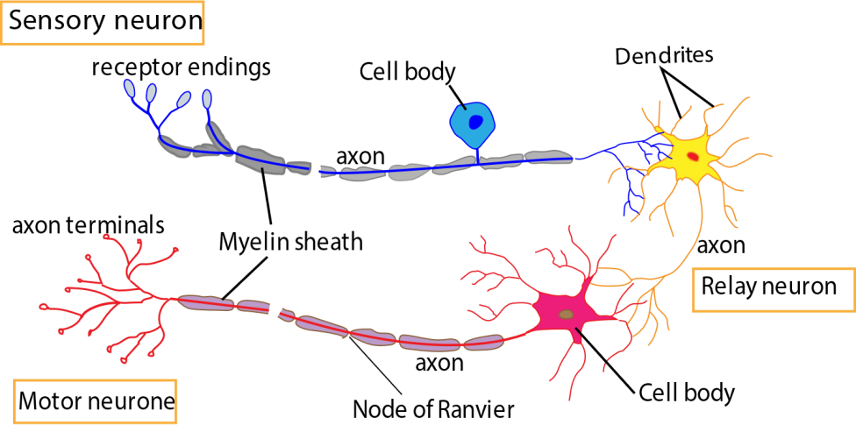

Differences between effector and sensory neurons
 | Effector neurons | Sensory neuron
1. | Transmit impulse from CNS to  the effector | Transmit impulse from sense organ or receptor to the CNS.
2. | Cell body at the end of the axon | Cell body in the middle of axon
3. | Cell body located in grey matter of spinal cord | Cell body located in dorsal root ganglion of the spinal chord

Structure of the nerve cell
- The cytoplasm contains the same organelles as the other body cell; mitochondria, nucleus cell membrane and ribosome grouped in Nissl’s granules.

- Along nerve fibre axon extend from the cell body in effector neurons or either sides of the cell body in sensory neuron to transmits impulses. The axon enclosed within a fatty myelin sheath which is not part of the neuron but another cell Schwann cell which wraps itself repeatedly round the axon. The myelin sheath protects the axon, but also insulates the axon and speeds up transmission of impulse.

Transmission of impulse
The resting potential of axon
A potential difference is maintained between the inside and outside of undisturbed axon. The inside being negatively charged [about- 70 mV] with respect to the outside. In this state the membrane is said to be polarized. The resting membrane potential is maintained by the sodium / potassium pump using energy derived from ATP and it pumps ions against their concentration gradient pumping sodium ions are pumped out of the neuron in exchange for potassium ion (K⁺). The concentration of K⁺ ions and organic ions is higher inside the neuron whereas the concentration of Na⁺ and Cl⁻ ion concentration is higher outside the neuron

The impulse
An impulse or action potential is a temporary and local reversal of the resting membrane potential, arising when an axon is stimulated. The term used during the electrical change which occurs during the passage of action potential is depolarization, and axon is said to be depolarized. The action potential is short- lived lasting about a millisecond, after which the resting membrane potential is restored. Events occurring into axon during the transmission of action potential are show in the figure below.
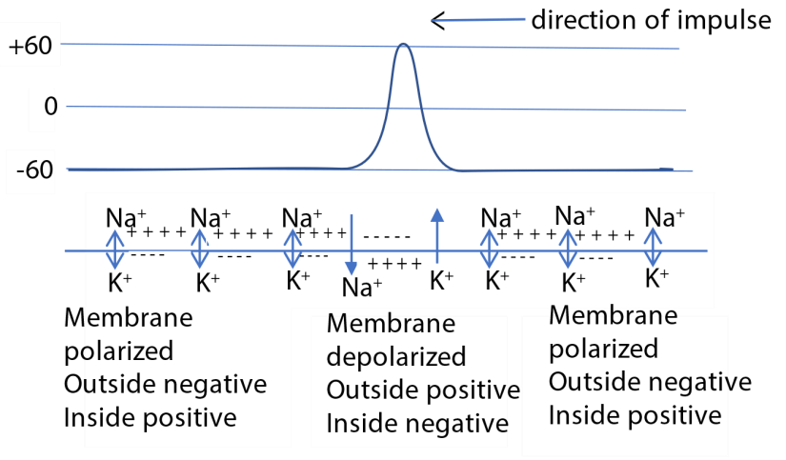
Information is transmitted through the nervous system as a series of impulse which travel as action potential.

Properties of nerves and impulses
Stimulation
In normal circumstance impulse are set up in nerve cell as a result of excitation of receptor. But an impulse can be set up in nerve by applying any stimulus which opens the sodium channels and cause depolarization of the membrane. In general nerve can be stimulate by mechanical, osmotic, chemical, thermal and electrical stimuli.
All or nothing law
An excitable tissue will only be excited by a stimulus above certain threshold stimulus intensity. For any given neuron the amplitude of the action potential is always constant and increasing the strength or number of stimuli has no effect on this. For this reason, potentials are described as all or nothing event. The all- or-nothing law states that the response of excitable unit (axon) is independent of the intensity.
Refractory period
After an axon has transmitted an impulse, it cannot transmit another one straight way. The axon has to be recovered first. The membrane has to be repolarized first.
The period of under which the nerve cannot transmit an impulse following the transmission of first one is called refractor period and typically lasts about 3 milliseconds. It can be divided into absolute refractory period during which the axon is totally incapable of transmitting an impulse, followed by a somewhat longer relative refractory period during which it’s possible to generate an impulse in the axon provided that the stimulus is stronger than usual.
The importance of the refractory period, together with transmission speed, it determines the maximum frequency at which the axons can transmit impulses. For most axons the maximum frequency is about 500 per second, though some neurons can reach 1000 per second.

Factors that affect nerve conduction velocity
- Axon diameter:
  - Impulses move faster in an axon with larger diameter because longitudinal resistance of exoplasm decreases with increasing diameter of axon, which increases the length of the membrane influenced by local circuit as the distance between adjacent depolarizations increases; causing increased conduction velocity.
  - Small cells or cells with large surface area: volume ratio or ion leakage weakens membrane.
  - Myelin sheath stops ion leakage; therefore, large diameter only important for unmyelinated neurons
- Myelination and saltatory conduction:
  - Myelination speeds up conduction. In a myelinated neuron, the conduction velocity is directly proportional to the fiber diameter.
  - Schwann cells prevent diffusion of ions; flow of current occurs only between adjacent nodes of Ranvier
  - Therefore, depolarization only at nodes of Ranvier because action potential jumps from node to node
- Temperature: Homoiotherms with steady body temperature have faster impulse propagation than poikilotherms which have fluctuating body temperature.

- Resting membrane potential: Effect of RMP changes on conduction velocity is quite variable. Usually, any change in the RMP in either direction (hyper polarization or depolarization) slows down the conduction velocity.

The Synapse.
This is a functional area, where an axon comes into contact with another for the purpose of transferring information. There are two types of synapses, electrical and chemical, depending on the nature of transfer of information across the synapse, A structurally dissimilar but functionally similar synapse exists between the terminal of a motor neuron and the surface of a muscle fibre and this is called neuromuscular junction.

Structure of the chemical synapse
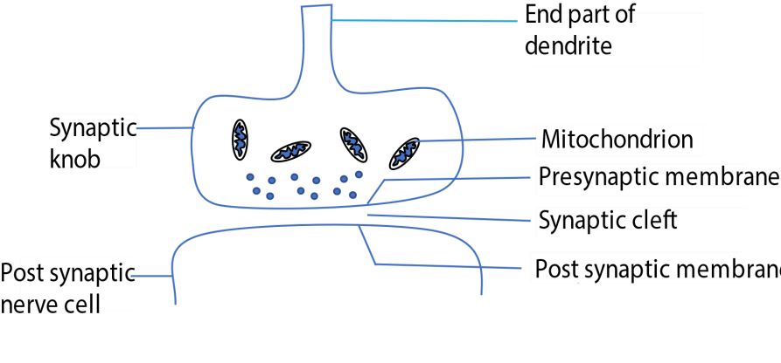

Transmission across a synapse.
- Arrival of an impulse at the synaptic causes an influx of Ca²⁺ ions into the knob from the synaptic cleft.
- The Ca²⁺ ion causes the synaptic vesicles to move towards the pre-synaptic membrane.
- The vesicles fuse with the pre- synaptic membrane and release a transmitter substance into the synaptic cleft by exocytosis.
- The transmitter substance diffuses across the synaptic cleft and attaches to specific receptor sites on the post synaptic membrane.
- This causes an influx of Na⁺ ion into post- synaptic membrane, resulting in local depolarization of the membrane. If the Na⁺ ion surge is large enough, an action potential (impulse) is generated in the post –synaptic neuron.

The transmitter substances
The transmitter substance at the majority of synapse is acetylcholine an ammonium base which has an effect on the permeability of the nerve membrane. After its effect, it’s inactivated by an enzyme cholinesterase to enable successive impulse to be kept separate. The products of this hydrolysis pass back into the synaptic knob where they are resynthesized into Acetylcholine using energy from ATP.
The Nerve- muscle junction or Neuromuscular.

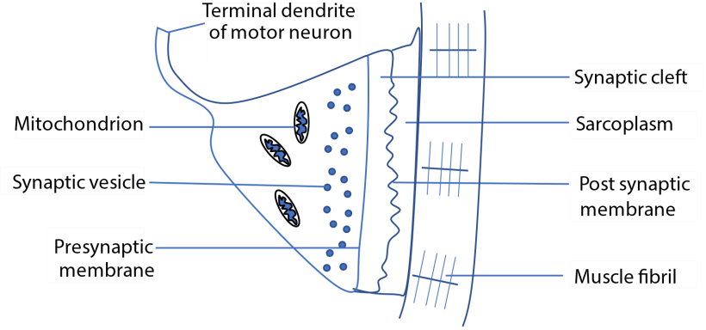
Transmission across the neural muscular junction is the same as in any other chemical synapse. When an impulse arrives at the nerve muscular junction, acetylcholine is discharged from synaptic vesicle into synaptic cleft. The acetylcholine diffuses across the gap and depolarize the muscle end plate.

Differences between inhibitory and excitatory synapses
Excitatory synapses increase the likelihood that a postsynaptic neuron will generate an action potential, while inhibitory synapses decrease this likelihood. The distinction between them lies in their effects on the postsynaptic membrane potential, the neurotransmitters they use, and the ion channels they activate.

How is the transmission across the synapse controlled?
- Neurotransmitter release regulation: The amount of neurotransmitter released depends on calcium ion influx into the presynaptic terminal. More calcium = more vesicle fusion = stronger signal.
- Availability of Neurotransmitters: The synthesis, storage in vesicles, and transport of neurotransmitters are regulated processes. The rate at which vesicles are refilled and
made available in the "readily releasable pool" influences how strongly a synapse can respond to sustained activity.
- Presynaptic Modulation (Axoaxonic Synapses): Some synapses form on the axon terminals of other neurons (axoaxonic synapses). These can regulate the amount of neurotransmitter released by the second neuron, either increasing (facilitation) or decreasing (inhibition) its effect on the postsynaptic cell.
- Autoreceptors: Receptors on the presynaptic membrane (autoreceptors) can detect the amount of neurotransmitter that has been released. If the concentration is too high, they can trigger a negative feedback loop to reduce further release.
- Enzymatic breakdown of neurotransmitters: Enzymes like acetylcholinesterase break down neurotransmitters (e.g., acetylcholine) in the synaptic cleft, stopping the signal.
- Reuptake by presynaptic neuron: Neurotransmitters like serotonin and dopamine are reabsorbed into the presynaptic neuron via transporter proteins, reducing their effect.
- Diffusion away from the synaptic cleft: Some neurotransmitter molecules diffuse out of the cleft, lowering their concentration and impact.
- Inhibitory neurotransmitters: Neurotransmitters like GABA cause hyperpolarization of the postsynaptic membrane, making it less likely to fire.
- Desensitization of receptors: Continuous stimulation can lead to receptor desensitization, reducing responsiveness to neurotransmitters.

Significance of warm-ups before physical activity in relation to transmission of impulses:
Before physical activity, warming up is significant for nerve impulse transmission because it increases the speed and efficiency of nerve signals, enhances communication within the nervous system, and improves neuromuscular control. These effects contribute to better performance, faster reaction times, and a reduced risk of injury during exercise.

Significance of the use of cold packs in first aid.
When an injury occurs, cold packs are used in first aid to significantly slow the transmission of nerve impulses, which reduces pain and limits the body's inflammatory response. This process is known as cryotherapy.

The role of local anaesthetics.
Local anesthetics reduce pain by blocking the transmission of nerve impulses from a specific area of the body to the brain. They do this by targeting and reversibly inhibiting the function of voltage-gated sodium (𝑁𝑎+) channels within the nerve cell membrane.

The action of drugs and poisons
Chemicals that destroys acetylcholine, inhibits its formation or prevents it’s action, will stop synaptic transmission.
Atropine, for example doesn’t prevent acetylcholine being formed but it stops it depolarizing the post- synaptic membrane and therefore cause synaptic block.
Curare, the poison used on the tips of arrows by south Americans Indians has a similar effect specially on nerve muscle junction.
On the other hand chemicals (e.g. serine) nerve gases that destroy or prevent the formation or action of cholinesterase will be expect to enhance and prolong the effects of acetylcholine.
Strychine also enhance synaptic transmission to such an extent that a person suffering from strychnine poisoning will give convulsive muscular contraction upon slightest stimulation.

Noradrenaline
This s another neural transmitter substance in sympathetic nervous system of vertebrates. Nerves that produce acetylcholine are called cholinergic nerve and those producing noradrenaline are called adrenergic.

Function of synapse
- Ensure unidirectional flow of impulse from neuron to the next.

- Amplifies the impulses by producing sufficient acetylcholine to excite post synaptic neurone.

- Adaptation or accommodation: The amount of transmitter substances released by a synapse steadily falls off in the response to constant stimulation until the supply of transmitter substance is exhausted and the synapse is described as fatigued. Further information passing along this pathway is inhibited and the adaptive significance of fatigue in the prevention of damage effect due to over stimulation.
- Integration: A post synaptic neuron receives stimuli from a variety of source and integrates them and produce a coordinated response.

- Discrimination: Temporal summation at synapse enable weak background stimuli to be filtered out before it reaches the brain e.g. information from receptor in the skin, the eyes and ears receive constant stimuli from the environment which has little immediate importance for the nervous system. Only changes in the intensity of stimuli are significant to the nervous system and these increase the frequency of stimuli and pass across the synapse and evoke a response.

- Inhibition: The transmission of information across a synapse and neuromuscular function may be prevented post-synaptically by the activity of certain chemical blocking agents or pre-synaptically.

The vertebrate nervous system
The nervous system of vertebrate is characterized by the structural and functional diversity of neurons and their complex organization with the body. The nervous system is subdivided into two main parts, the central nervous system [CNS] and peripheral nervous system.
The central nervous system consists of brain and spinal cord while peripheral nervous system consists of numerous nerves which link the CNS with the receptors and effectors.

Reflex action and reflex arch.
The reflex action in a rapid, automatic stereotyped response to a stimulus which is not under the conscious control of the brain. It’s also described as involuntary action. The neurons forming the pathway taken by the nerve impulse in reflex action is referred to as reflex arch. Illustrated below:
The reflex arc
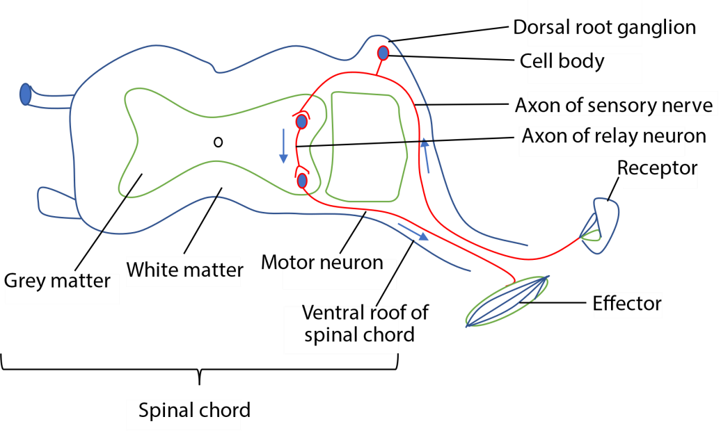

Conditioned reflex arch
This is a form of reflex action where the response is modified by the past experience; it’s coordinated by the brain. Learning forms the basis of all conditioned reflexes such as salivation at sight or smell of food.

The autonomic nervous system
The autonomic nervous system is the part of the peripheral nervous controlling activities of the internal environment that normally involuntary such as heart rate, peristalsis and sweating.
The autonomic system is divided into two parts; the sympathetic and parasympathetic system. Both contain nerve fibres serving structures over which the body has little or no voluntary control. In both cases nerve fibres emerge from the brain or spinal cord and pass to the organs concerned. There are many pathways in each of the two systems. Along the course of each pathway there is a complex set of synapses constituting a ganglion. The nerve fibres on the proximal side of the ganglion are called pre- ganglionic fibre, those on the distal side post- ganglionic fibres,
The main structural difference between the parasympathetic and sympathetic system relate the position the ganglion and are given below.
 | Sympathetic | Parasympathetic
 | Structural differences
1. | ganglia lie close to the vertebrate | Ganglia are embedded in the walls of the effector
2. | Preganglionic fibre short | Long preganglionic fibre
3. | Long post ganglionic fibre | Short post ganglionic fibre
 | Functional differences
4 | Transmitter is noradrenaline | Transmitter substance is acetylcholine
5. | Accelerates heart beat | Slow heart beat
6. | Dilate bronchioles | Constricts bronchioles
7. | Dilates iris | Constricts iris
8. | Slows gut | Speeds up gut movement
9. | Constricts bladder and anal sphincter | Relaxes bladder and anal sphincter
10 | Cause relaxation of bladder | Causes contraction of bladder
11. | Contracts erector pili muscles | -
12. | Increase sweat secretion | -
13. | - | Stimulates tear glands
14 | - | Causes flow of saliva and other secretion

The brain
The brain is swollen anterior end of the vertebrate neural tube which has the over role of the coordination and control of the activities of the whole nervous system. To accomplish this there are special centers or nuclei in the different parts of the brain for dealing with specific functions such as locomotion, balancing and so on

Functions of the brain
1.Recieves impulses from receptors
2.Intergrates these impulses
3.sends out new impulses to the appropriate effect.

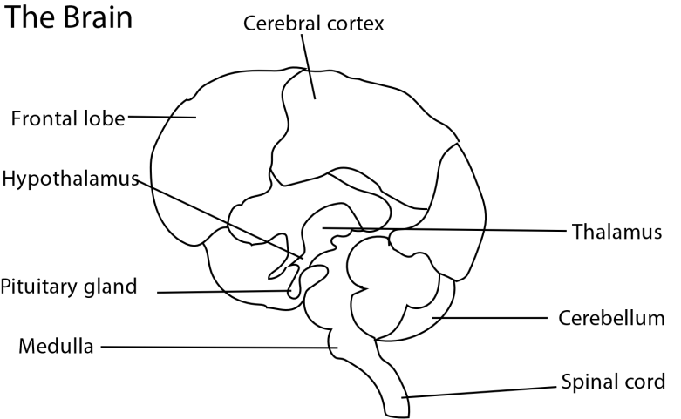

Function of the main parts of the brain the human brain.
- Medulla oblongata is the most posterior part of the brain. It contains centers controlling breathing, circulation, swallowing , salivation and vomiting.
- The cerebellum coordinates voluntary movements such as posture, balance, coordination, and speech, resulting in smooth and balanced muscular activity. It is also important for learning motor behaviors
- The thalamus and associated structures: contain centers controlling such function as sleep, aggression, feeding, drinking, osmoregulation, temperature regulation, speech and sexual activity.
- Pituitary is an endocrine gland that secretes a wide range of hormones controlling such function as water and salt balance, growth, metabolism and sexual development.
- The cerebral hemispheres coordinate all voluntary response.

Hormonal communication
Hormones are organic compounds produced in one part of the body, from which is transported -usually in the blood stream – to another part when it evokes a response.
In the human and other vertebrate hormones are secreted into the blood stream by endocrine glands.
Position of the main endocrine gland in a human body

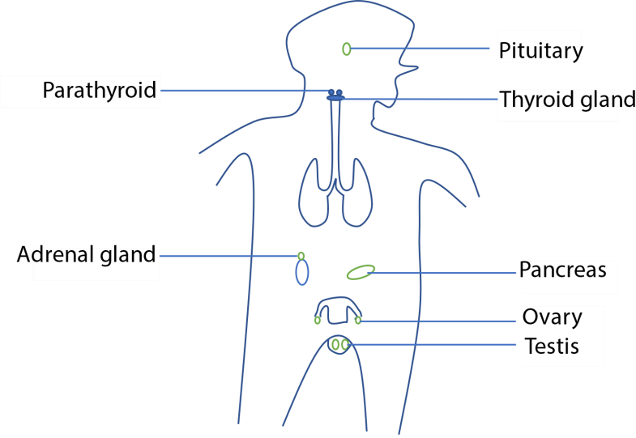

The principle endocrine glands of mammal, hormones and functions of the hormones
 | Gland | Hormone | main function
a. | Thyroid | Thyroxine | Raise basal metabolic rate
a. | Thyroid | Calcitonin | Opposes action of parathormone
b. | Parathyroid | Parathormone | Controls concentration of calcium and phosphate ions in blood
c. | Pancreas | insulin | lows blood sugar concentration
d. | Adrenal  medulla | adrenaline | prepare body for emergency; metabolic rate increases,
e. | Adrenal cortex | Aldosterone | Controls concentration of K⁺ and Na⁺ in blood
e. | Adrenal cortex | Cortisol | Prevent excessive immune response
e. | Adrenal cortex | androgens | Promotes development of testes and secondary sexual characteristics
F | Pineal body | melatonin | causes concentration of melanin in frog’s  skin; promote sexual development in mammal
g. | Testes | Androgens | Promotes development of testes and secondary sexual characteristics
h. | Ovaries | Estrogens | promotes development of ovaries secondary sexual characteristic of female control menstrual cycle and pregnancy.
I | Pituitary  (anterior lobe) | Thyroid stimulating hormone | Causes the thyroid gland to secrete thyroxine
I | Pituitary  (anterior lobe) | Adreno corticotrophin (ACTH) | Cause adrenal cortex to secrete adrenal cortical hormones
 |  | Growth hormones | Stimulate growth
 |  | prolactin | Causes mammary gland to secrete milk
 |  | Follicle stimulating hormone | Controls testes and ovary
 |  | Luteinizing hormone | Controls testes and ovaries
 | Pituitary  (posterior lobe) | Antidiuretic hormone (ADH) | Causes reabsorption of water in kidney
 | Pituitary  (posterior lobe) | oxytocin | Causes contraction of uterus at birth

How hormones control cells
When a hormone molecule reaches a target cell, it binds to the plasm membrane at a specific receptor site. The receptor site is located on the outer surface of the membrane and is associated with a molecule of adenylate cyclase. The binding of hormone to the membrane increases the activity of adenylate cyclase, causing ATP to convert into cyclic AMP. The cyclic AMP [Adenosine monophosphate] then activate enzymes which bring about the appropriate response with in the cell. The extent of the particular response is determined by the concentration of cyclic AMP which in turn depends on a delicate balance between adenylate cyclase responsible for synthesis, and another enzyme phosphodiesterase - which destroys it.

Receptors cells
These cells that convert energy associated with stimulus to an electrical impulse in the nerve or nerve impulses.
Receptors are classified according to the type of stimulus they respond to: -
- Chemoreceptors are stimulated by chemicals e.g. receptors mediating the sense of smell, taste and receptors that detect changes in levels of respiratory gases in the body.
- Mechanical receptors are stimulated by mechanical stimuli e.g. touch, pressure, tension (stretch) and sound
- Photoreceptors are stimulated by light e.g. eyes.
- Thermo-receptors are stimulated by heat.

Mechanism of receptor cells
When receptor cells receive appropriate stimulus, they develop a generator potential (local depolarization) depending on the size of the stimulus. However, when stimulus is strong enough, the generator potential may build up to fire an action potential in the adjacent nerve fibre. If the generator potential is maintained after an action potential has been conducted away, a second one will be fire off.

Properties of receptors.
- Specificity: Each receptor responds to a particular type of stimulus (e.g., light, sound, pressure, chemicals).
- Excitability: They can generate electrical signals (impulses) when stimulated relevant stimuli above a threshold.
- Adaptability: Some receptors adjust their sensitivity over time, allowing them to filter out constant stimuli (e.g., touch receptors).
- Transduction Ability: They convert external stimuli into electrical impulses that the nervous system can interpret.
- Connectivity: Receptor cells are connected to sensory neurons, enabling signal transmission to the brain or spinal cord.
- High Sensitivity: Many receptors can detect very weak stimuli, ensuring effective response to environmental changes.
- Precision: Receptors are precise in transmission of information. They receive and transmit the exact information about a stimulus without any alteration. This ensures that they send the exact information to the brain about the changes in the environment.
- Inhibition: The transmission of certain impulses in the receptors can be inhibited. This is important because it ensures that the receptors transmit only that information which is of use to the organism it a particular time.

Mechanisms Ensuring Receptor Efficiency
- Structural Specialization: Receptors are shaped and positioned to maximize stimulus detection (e.g., rods with stacked discs, cochlear hair cells aligned to sound waves).
- High Sensitivity to Specific Stimuli: Each receptor type responds best to a particular form of energy (light, sound, pressure), reducing noise and improving accuracy.
- Transduction: all receptors are capable of converting a physical stimulus into electrical impulses. This ensures that each stimulus is registered in form of an electrical impulse.
- Adaptation Mechanisms: Receptors can adjust their sensitivity over time (e.g., light adaptation in cones), preventing overload and maintaining responsiveness.
- Amplification of Signals: Biochemical cascades (e.g., in photoreceptors) amplify weak stimuli, ensuring even faint signals are detected.
- Convergence increases sensitivity (e.g., rods pooling signals).
- Divergence spreads signals for broader processing and integration.
- Rapid Recovery and Reset: Efficient resynthesis of pigments or ion channel resetting allows receptors to respond repeatedly and reliably.
- Protective Structures: Surrounding tissues (e.g., cornea, ear canal) help filter and focus stimuli, enhancing receptor performance.

The eye
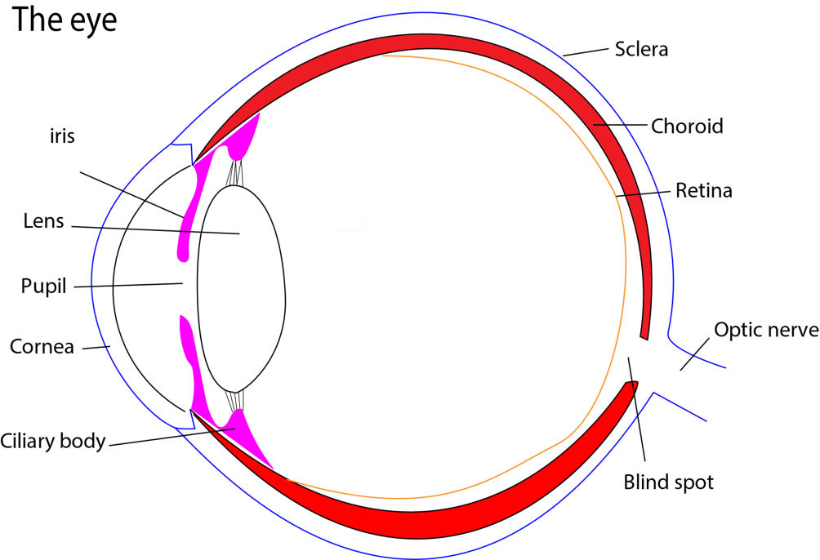

Functions of the parts of the eye
- Lens refracts light to the retina
- Iris adjust the size of the pupil
- Retina is where the image forms
- Pupil allows light to pass through into the eye.

Controlling amount of light entering the eye
The amount of light entering the eye is controlled by the iris.
In bright light, the iris circular muscles to contract and pupil constricts.
In dim light iris radial muscles contract and the pupil widens

Accommodation
Is the ability of the eye to view near and far objects.
- To see near objects, the ciliary muscle contract releases the tension on the lens allowing it to adopt a more spherical shape. The lens then refracts light strongly.
- To view distant objects, the lens is flattened by relaxation of the ciliary muscle which springs outwards.

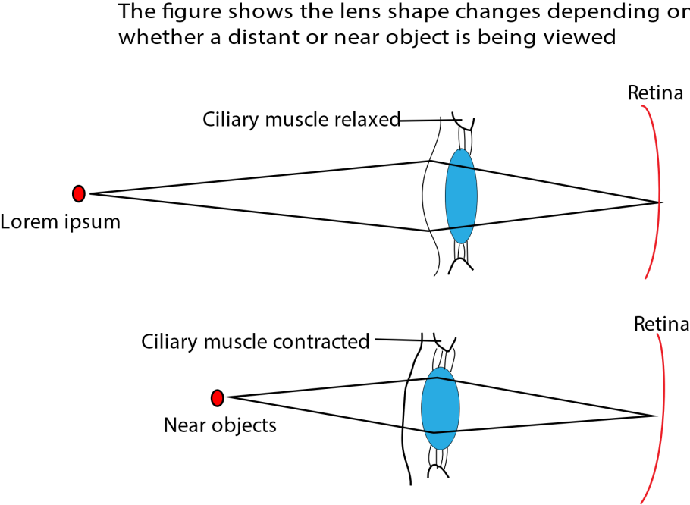

The retina
The retina contains two types of photoreceptor cells: rods and cone.

The cones are found over most of the retina but are particularly concentrated in the centre directly behind the lens. This called the fovea. The rods on the other hand lie outside the foveal region in the more peripheral part of the retina.
The cones enable us to perceive the environment in good illumination and are responsible for daylight vision. They enable us to see things clearly and sharply and in color. However, they are relatively insensitive to low light intensities and this is why they will only work in good light.
The rods enable us to perceive the environment in conditions of low illumination. In other words, they are responsible for night vision. They are sensitive to very small light intensities of light, which is why they can operate at low-level illumination. Rods do not register things as clearly and sharply as the cones do, and they cannot respond to different colours so they only allows to see things in black, white or various shades of grey.
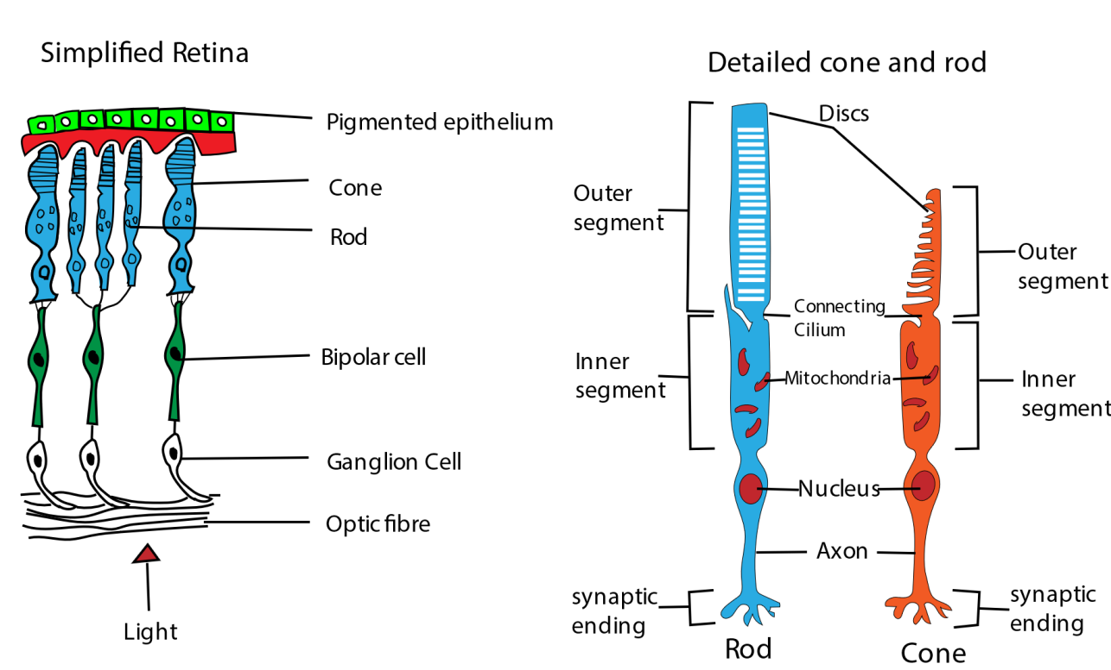
Notice that
- A group of rods converges on to a single optic nerve fibre. This allows summation to occur and increases overall sensitivity.
- A single cone is connected to a single bipolar cell, which allows precision.

Differences between rods and cones
Rods | Cones
Outer segment rod shaped | Outer segment cone shaped
Rods occur in large number | Concentrated in fovea
Have low visual acuity | Have high visual acuity
Very sensitive to light | Low sensitivity to light
Insensitive to color | Sensitive to color
Has one form of rhodopsin | Has three forms of rhodopsin

The significance of the distribution of photoreceptor cells in the eye
The uneven distribution of photoreceptor cells—rods and cones—significantly shapes our vision by creating a system that combines low-light sensitivity with high-resolution color perception. The fovea, the retina's central point, is densely packed with cones for sharp, detailed color vision in bright light, while the surrounding retina has a much higher density of rods for detecting movement and vision in dim light, as well as for peripheral vision.

Mutual or Lateral inhibition
This occurs when the activity of one cell suppresses the activity of a nearby cell or when activation of one cell by light impairs or prevents neighboring cells from being activated.

Importance of mutual or lateral inhibition
- This causes the edges between light and dark areas to appear more prominent than they would be otherwise
- Lateral inhibition disables the spreading of action potentials from excited neurons to neighboring neurons in the lateral direction.

Transduction of light in rods
- Photo-transduction is the process in which light is converted into electric signal in rods and cone cells of the retina.
- Both rod cells contain a photopigment, Rhodopsin.
- Rhodopsin contains retinal (aldehyde of vitamin A) a light sensitive molecule covalently linked to a protein called opsin.
- When struck by light retinal (in cis form) isomerizes to a trans- form.
- Isomerization of retinal activates rhodopsin to start a cascade of events leading to firing of impulses to the brain.
- After depolarization, trans form of retinal is converted back to the cis form to be reused using ATP energy.

Light Transduction in Cones
- Light Absorption: Light hits the cone cell and activates photopsin, the pigment specific to red, green, or blue cones.
- Pigment Activation: 11-cis-retinal in photopsin converts to all-trans-retinal, triggering a conformational change in opsin.
- Signal Cascade: Activated opsin stimulates transducin (a G-protein). Transducin activates phosphodiesterase (PDE), which breaks down cGMP.
- Ion Channel Closure Reduced cGMP causes Na⁺ channels to close, leading to hyperpolarization of the cone cell membrane.
- Neurotransmitter Modulation Hyperpolarization reduces glutamate release, altering the signal received by bipolar cells.
- Signal Transmission: Bipolar cells relay the signal to ganglion cells, which send impulses via the optic nerve to the brain.

Sensitivity of the retina
Rods are more sensitive to light than cones because
- their photochemical pigment of rods responds to very low light intensities.
- Numerous rods make synaptic contact with a single bipolar neuron which in turn connects with cell body of a single optical nerve fibre. A phenomenon called Retinal convergence.

Retinal convergence
Retinal convergence is a neurological process where multiple photoreceptor cells (rods and cones) transmit signals to a smaller number of downstream retinal ganglion cells.

Retinal convergence increases the sensitivity of the eye because simultaneous excitation of a number of rods is more likely to generate an impulse in the optical nerve than excitation of a single rod would not.

Precision of the eye
The ability of the eye to distinguish between two distant points as distinct points is called visual acuity. Visual acuity is due to cones.

Color vision
There are three types of cones each corresponding to light of different wavelength. Each cone absorbs light of red, green or blue and this has given rise the trichromatic theory which state that different colors are produced by the degree of stimulation of each type of cone.

Adaptation of rod cells
- High Sensitivity to Light: Contain rhodopsin, a pigment that responds to even very low light levels. This enables night vision and detection of dim stimuli.
- Long Outer Segment: Packed with stacked membrane discs rich in rhodopsin. This increases surface area for light absorption.
- Convergence of Signals: Multiple rod cells synapse onto a single bipolar neuron. This enhances sensitivity by summing weak signals, though at the cost of visual acuity.
- Peripheral Distribution: Concentrated in the retinal periphery, ideal for detecting motion and shapes in dim light.
- Slow Adaptation to Light Changes: Rods adapt slowly to changes in light, allowing sustained function in darkness.
- Contain numerous mitochondria to provide energy for synthesis of bleached photopigment

Adaptations of cones
- Color Sensitivity: Cones contain photopsins tuned to different wavelengths: red, green, and blue. This enables trichromatic color vision in bright light.
- High Visual Acuity Densely packed in the fovea, where each cone connects to a single bipolar neuron. This allows sharp, detailed vision.
- Rapid Response to Light Changes: cones adapt quickly to changes in light intensity, ideal for daylight vision.
- Low Convergence: minimal signal pooling preserves fine spatial resolution, unlike rods which sacrifice detail for sensitivity.

Reasons for high sensitivity of Rods to light
- Presence of Rhodopsin: Rods contain rhodopsin, a pigment that can be activated by very low light levels, making them ideal for night vision.
- High Pigment Density: Their outer segments are packed with stacked membrane discs, increasing the surface area for light absorption.
- Signal Convergence: Multiple rods connect to a single bipolar neuron, allowing summation of weak signals, enhancing sensitivity.
- Low Activation Threshold: Rods require minimal light to trigger a response, unlike cones which need brighter light

Reasons for high visual acuity of cones

- Dense concentration in the fovea: The fovea centralis is packed with cones and is the region of sharpest vision.
- One-to-one synaptic connections: Each cone typically connects to a single bipolar cell, which connects to a single ganglion cell.This preserves spatial detail without signal pooling.
- Fast response and recovery: Cones adapt quickly to changes in light, allowing precise tracking of fine details in bright conditions.
- Specialized for daylight and color Their ability to detect color and fine contrast enhances clarity and resolution.

Compound eye
The compound eye is composed of numerous “mini eyes” ommatidia. Each ommatidia contain a group of photoreceptor cells which function as a unit.
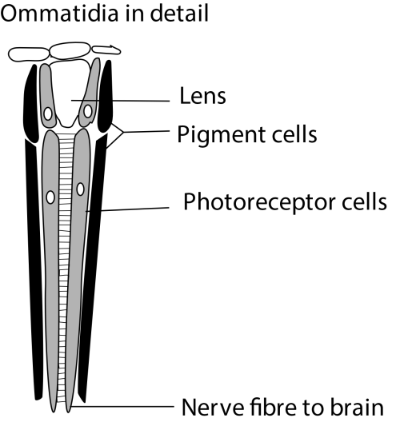
Reasons why it is difficult to catch a fly
This ability stems from several key biological advantages:
- Faster Visual Processing: Flies have a much higher "flicker fusion rate" than humans. They can process approximately 250 images per second, whereas humans process around 60 per second. To a fly, a human's swatting hand appears to move at a very slow, "sluggish" pace, giving them ample time to react and escape.
- Rapid Reaction Time: Flies have exceptionally fast visomotor reflexes. Once they visually detect a looming threat, they can adjust their posture and take off within a fraction of a second (around 20 milliseconds), much faster than a human's average reaction time (around 100 milliseconds).
- Near 360-Degree Vision: Their compound eyes provide a wide field of vision, allowing them to spot threats approaching from almost any direction, making it nearly impossible to sneak up on them.
- Neural Efficiency: Due to their small size, the distance nerve impulses must travel from the eye to the brain and then to the muscles is very short, facilitating a faster overall response time.
- Halteres: Flies possess specialized, dumbbell-shaped organs called halteres that act like gyroscopes, providing stability and balance during their rapid and complex escape maneuvers.

Comparison of compound and human eyes
Similarities
- both have lenses
- have light sensitive cells allow eye to collect data that is interpreted by brain to form images
- both have photo-pigments
Differences
Character | Human eye | Compound eye
Field of view | Narrow | Wide because it covers a big part of the head
Number of visual unit | One per eye | Many (omatia) per eye
Regulation of light into the cell | Light is regulated by iris | Does not regulate light
Visual acuity | High visual acuity due to high density of sensitivity cells in  the retina | Low visual acuity due to  - low density of light sensitive cells (omatidia)  - small lenses leading to high diffraction of light  - have small brains that cannot interpret detailed images.
Critical flicker frequency | Low | High
Color vision | Distinguish between colors | Not all compound eyes can distinguish between colors

Definition
Critical flicker frequency threshold is defined as the frequency at which a flickering light is indistinguishable from stead light.
Insects have high critical flicker frequency because they can process light fast because
(i) their rhodopsin is easily resynthesized (ii) their eye is closer to the brain.
(iii) they form simpler images
The high flicker frequency in insects allows then to detect movement faster than man.

Eye defects
Short sightedness is inability to see distant objects clearly because rays from a distant object are focus in front of the retina.
Causes (i) Lens too strong
(ii) eyeball too long
Correction: by use of a concave or diverging lens

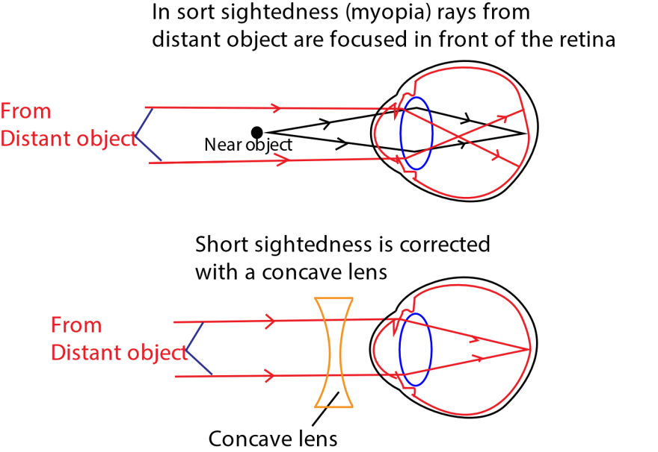
Long sightedness is inability to see near objects clearly because rays from a near object are focused behind the retina Cause (i) lens too weak
(ii) eyeball too short
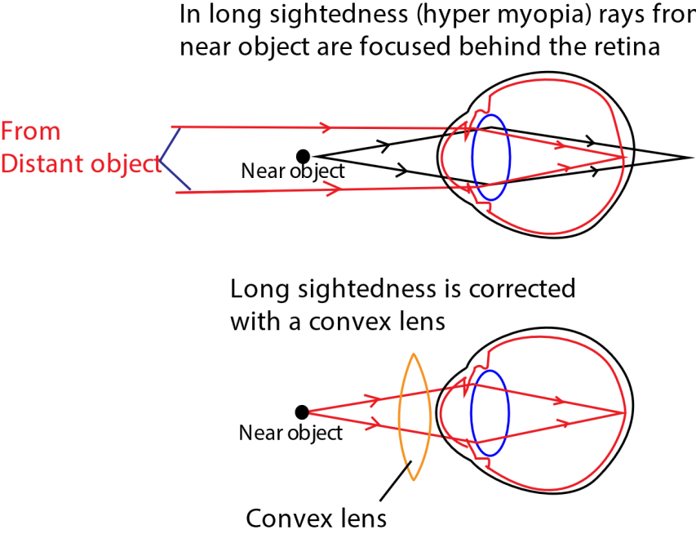
Correction: by use o
f a convex lens

The human Ear
The mammalian ear has two major functions
- Detecting sound
- Maintenance of body balance
Structure of mammalian ear
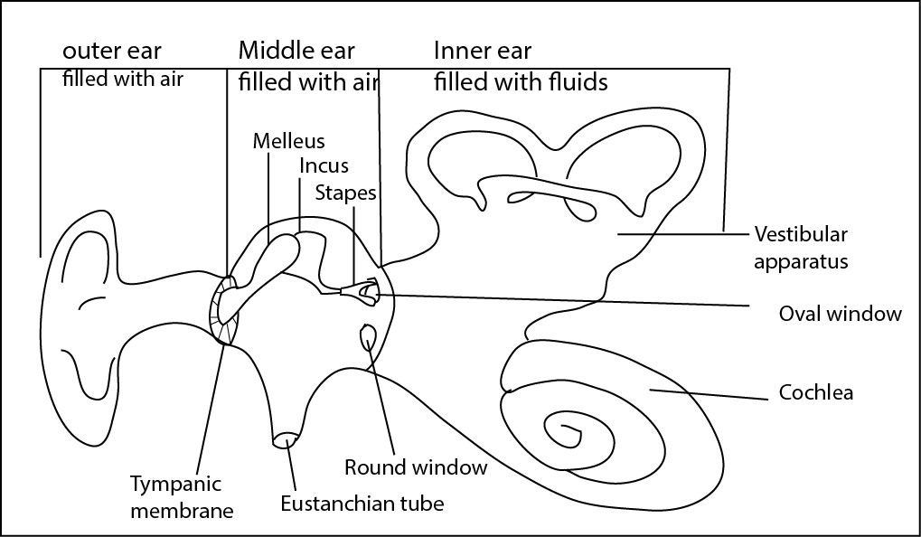
The has three main parts
- Outer ear
- Middle ear (c) Inner ear
The middle ear is separated from the outer ear by tympanic membrane, or ear drum. The middle ear is separated from the inner ear by an oval window (fenestra ovalis) and round window (fenestra rotunda) both of which are covered by membranes.
Spanning the middle ear from the tympanic membrane to the oval window is three tiny bone called ossicles (the malleus, incus and stapes). The Eustachian tube, which connects the middle ear with the pharynx, ensures that the air pressures on the both side of the tympanic membrane are equal.
The inner ear is made up of two parts, the vestibular apparatus and the cochlea. These two parts of the inner ear are continuous with each other though they carry out separate functions. The entire inner ear is filled with a fluid called endolymph and is separated from the wall of the skull by another fluid called perilymph. The vestibular apparatus is responsible for the sense of balancing while the cochlea is for hearing.

The cochlea
It consists of a coiled tube, which is divided longitudinally into three parallel canals: vestibular (connecting with the oval window). Membranes separate the three canals from each other: Reissner’s membrane between the vestibular and tympanic canals, and the Basilar membrane between the middle and tympanic canals. All the three canals are filled with fluid: endolymph in the middle canal and perilymph in the other two canals.
The relationship between the canals and membranes is shown in the cross section below:

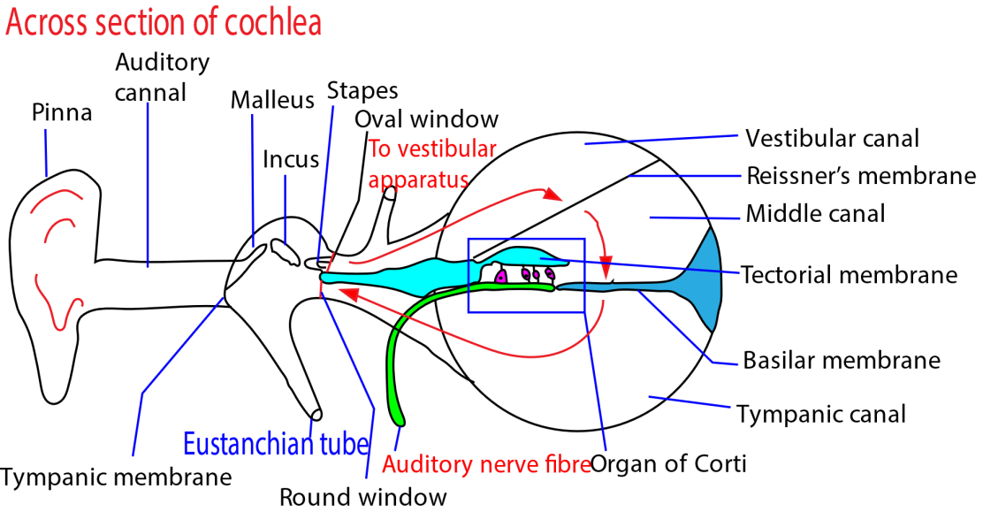
The cross section also shows the receptor cells that respond to sound. Into the middle canal projects a shelf, the tectorial membrane, this runs parallel with the basilar membrane for full length of the cochlea. Receptor cells span the gap between the basilar membrane and tectorial membranes. Their bases are rooted in the basilar membrane where they are connected to nerve fibres that join the auditory nerve. At the other end they bear fine hairs which just reach the tectorial membrane. This is the part of the cochlea that actually responds to sound and is called Organ of Corti
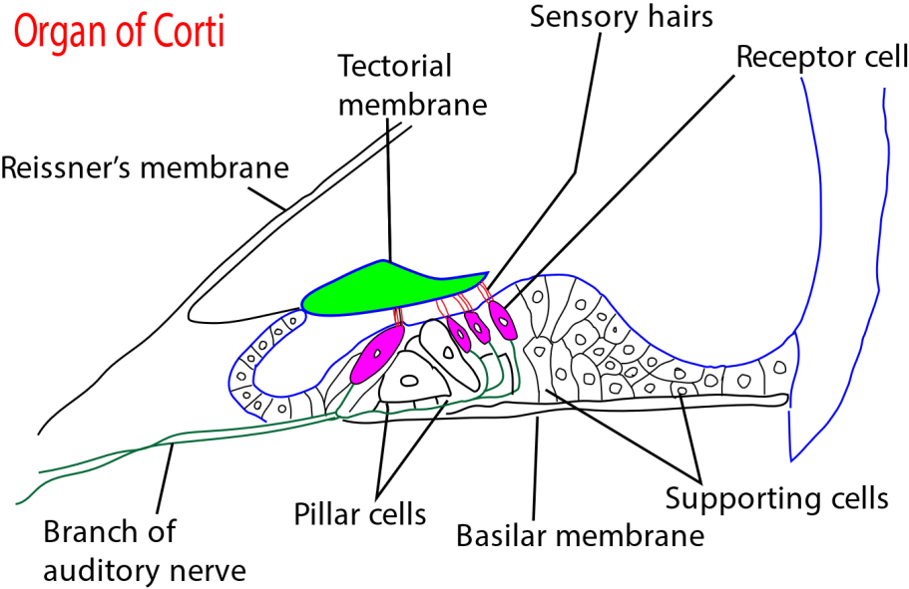

How Hearing occurs
- Sound waves impinge on tympanic membrane that vibrates accordingly.
- The movement of the tympanic membrane are transmitted by the three ossicles to the oval window
- This causes displacement of fluid in the vestibular canal which; in turn causes movement of Reissner’s membrane.
- Vibration of Reissner’s membrane displaces fluid in the middle canal which move the basilar membrane, thereby displacing fluid in tympanic canal
- Displacement of the fluid in the tympanic canal is taken up by stretching of the membrane covering the round window.
- The vibration of basilar membrane distorts the sensory cells of Organ of Corti, which fire impulses to the brain.
- The pitch of sound is determined by the frequency of vibration of the basilar membrane determine by the frequency of sound
- The intensity or loudness of sound is determined by the amplitude of the vibration of basilar membrane in turn determined by amplitude of sound.

The analysis of sound frequencies by the basilar membrane
The fibres of the basilar membrane become progressively wider and more flexible from the base of the cochlea to the apex. As a result, each area of the basilar membrane vibrates preferentially to a particular sound frequency.
The higher the frequency of the sound imposed the shorter the distance the waves travel.
Thus, a tone of a given frequency causes stimulation to reach a peak at a certain place on the basilar membrane. The region that vibrates most vigorously stimulates the greatest number of hair cells in that area of the organ of Corti, and these hair cells send the most nerve impulses to the auditory nerve and the brain. The brain recognizes the place on the basilar membrane, and thus the pitch of the tone, by the particular group of nerve fibres activated.
- High-frequency sound waves cause maximum vibration of the area of the basilar membrane nearest to the base of the cochlea;
- medium-frequency waves affect the centre of the membrane;
- low-frequency waves preferentially stimulate the apex of the basilar membrane.

The locations of cochlear frequencies along the basilar membrane shown are a composite drawn from different sources below:
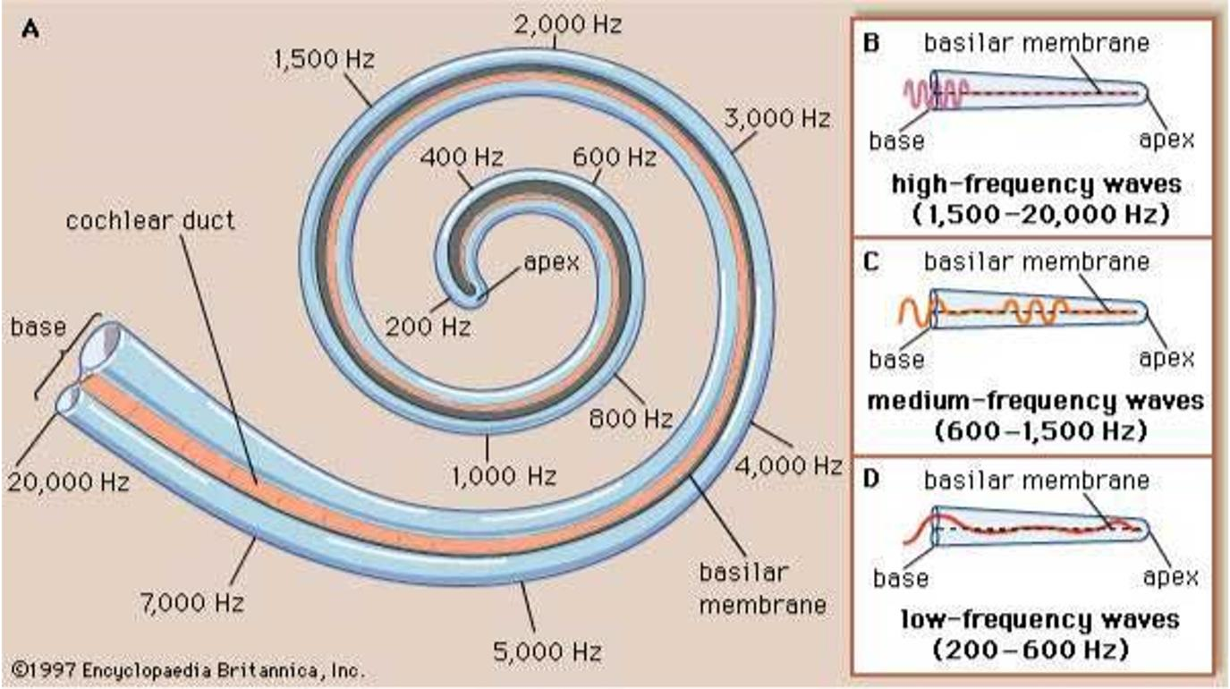

The vestibular apparatus
The vestibular apparatus responsible for the sense movements in body and maintenance of dynamic equilibrium consists of three semicircular canals in planes at right angles to each other.
At one end of each semicircular canal is a swelling (ampulla) which contains a receptor called a crista.
Each semicircular canal connects to two sacs called saccules and utricle often called Otolith organs.
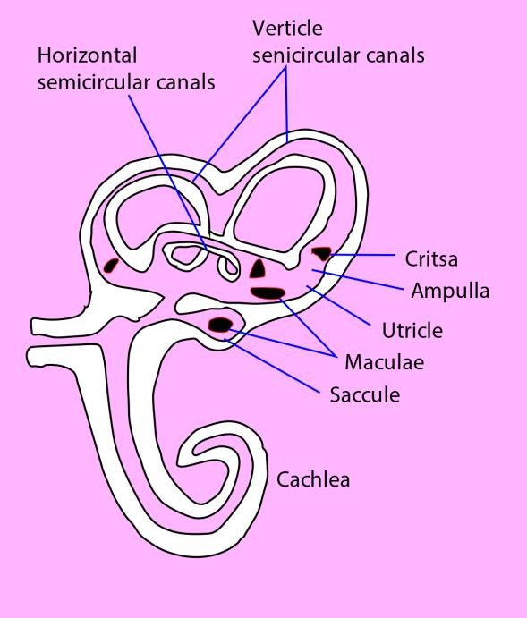
The ampulla
The ampulla contains of a group of receptor cells with hairs embedded in in a dome shaped gelatinous cap, the Cupula sensitive to movements of the head.
The fact that, the three canals are in different planes ensures sensitivity to movement in any plane.
Because of inertia of the fluid in the semicircular canals, movement of the head deflects the ampulla in an opposite direction as shown by the figure below.

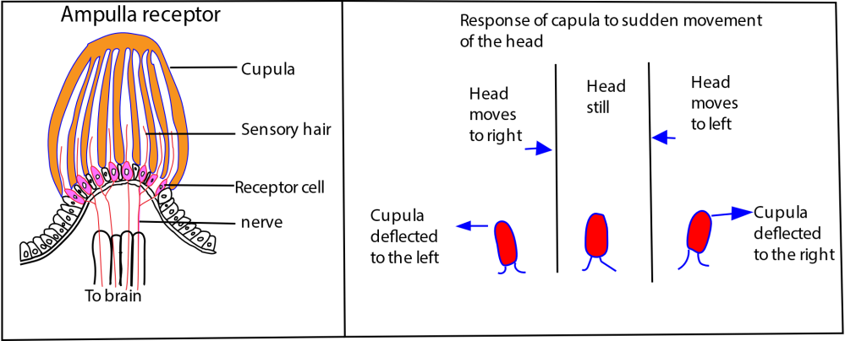
The deflection of the cupula puts mechanical strain on receptor cells, causing them to fire impulses to the brain

The utricle and saccule
The utricle and saccule contain specialized group of cells called macula that give information on the position of the head.
Macula consists of a group of receptor cells, the free ends of which are embedded in a gelatinous substance containing a high concentration of dense particles of calcium carbonate called otolith. The role of otolith is to increase inertia.
According to the position of the head, the pull of gravity on the Otolith vary as shown in the diagram below.
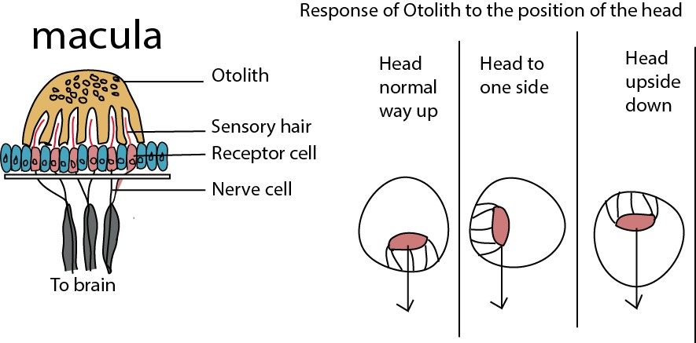
The differential distortion of the receptor cells resulting from the head being held in difference position determines the pattern of impulses discharged by the nerve fibre to the brain.
Because of the way they are situated within the vestibular apparatus, the saccule is more sensitive to vertical acceleration (like riding in an elevator) and the utricle is more sensitive to horizontal acceleration (riding in a car).

Animal behaviors
Behaviors
They are responses to the stimuli animals receive. Those animals that respond appropriately to changes in their environment are more likely to survive and reproduce.
A stimulus is anything that causes an action or reaction from something else.
The development of behaviors
To almost all behaviors there are two components one is instinctive and one learned.eg fish instinctively swim when they first take to water. Instincts are genetically inherited from parents and handled down in evolution. In most cases instinctive behaviors are common to all members of a species. Like structural features such as limb, instincts are subject to natural selection. However, with practice fish learn to swim more effectively.

Instincts
Instinctive behavior is an innate (inborn), stereotyped response to one or more environment stimuli, characteristics of organism of a given species Characteristic of instincts include:
- Are inherited and not acquired. That is, they develop independent of the environment • Are usually of immediate adaptive value to the organism.
- Are produced unconsciously in response to sudden change in the environment.
- Are similar in all members of a species and develop even in isolation. They include

Reflex.
A reflex is a simple act of behavior in which a stimulus produces a specific short-lived response.
Foe example of reflex
- Escape response of the earthworm i.e. when they hit an obstacle they quickly disappear into their burrows.
- Quick removal of hands from a hot object.

Ecological importance reflex behavior
- Rapid response to a stimulus, helps minimizes any damage to the body from potentially harmful conditions, such as touching something hot.
- Knee jerk help us in balance
- Reduce energy that would be required to plan and actively execute every tiny movement we make.
- reduces chances of the earthworm being eaten by foxes or other predators.

Kinesis
Alternative definitions
- is a behavior pattern in which an animal responds to an alternation in stimulus intensity by changing its activity level.
- is the movement of an organism in response to a stimulus, but it does not result in movement directly towards or away from the stimulus.
- Kinesis is a random (non-directional) movement in response to a stimulus

Difference between kinesis and taxis
Kinesis is a random (non-directional) movement in response to a stimulus while taxis is a directional movement away or towards a stimuli

Example of kinesis
- Woodlice like damp conditions. If the environment is too dry, they will move more often (although in random directions), until they find a damp environment. They will then move less often to try and stay in that environment. Note that the movement is non-directional but the organism simply moves more, or less in response to a stimulus.
It’s important to emphasize that wood lice don not move up the gradient of humidity. They simply move more in a non-humid environment. Eventually by sheer chance they are likely to reach a more humid environment. The result of this behavior is that wood lice spend most of their time in moist habitats.
- When a light is turned on, the cockroach will quickly start running - not necessarily away from or towards the light. This is kinesis, as it is just movement as a response to the stimulus of the light being turned on and not associated with a direction.
- Kinesis is movement triggered by increased activity such as an animal that feels cold, hot, hungry or angry.

Ecological importance of kinesis
- This adaptive movement helps organisms find a suitable environment, survive, and reproduce by ensuring they spend more time in preferred conditions. For example, by moving faster in dry areas and slower in moist ones, woodlice can increase their chances of finding a humid habitat to avoid desiccation.
- By moving faster in the open, organisms can increase their chances of leaving an unfavorable or exposed area, helping them to avoid predators.
- It increases the chances of finding resources and favorable conditions by sheer luck. For instance, some predators may increase their search speed between resource-rich areas and slow down their movement within these areas to search more efficiently.

Taxis
Taxis is a movement that oriented in relation to the direction of stimulus

Examples of taxis
- Euglena swims towards light. Euglena is said to be positively phototactic. Earth worms move away from light and are therefore negatively phototactic.
- The mosquito moves towards the carbon dioxide source in order to find food.
- Moving toward a source of sent to find ripe fruit/food.

Ecological importance of taxis
The significance of taxi behavior is that it enables organisms to move towards beneficial stimuli (positive taxis) like food, mate or shelter, or away from harmful ones (negative taxis), aiding survival, reproduction, and navigation. This innate, directional movement helps organisms find resources, avoid predators, and maintain homeostasis by responding to environmental cues such as light (phototaxis), chemicals (chemotaxis), and gravity (geotaxis)

Sign of stimuli.
It is a stimulus that produces a selectively stereotyped response. Such selective behavior is adaptive because it allows an animal to respond immediately in an appropriate way to relevant aspect of its environment and to ignore others.
Example;
- the two eyes constitute the sight stimulus which cause the baby smile.
- The red spot of herring gull’s yellow beak is a sign stimulus that directs its chicks to peck at its beak to receive food.
- The swollen abdomen of stickleback is the sign stimulus to attract male stickleback.

Learning
It refers to a more or less permanent change in behavior which occurs as a result of experience. Animals vary in how much they are capable of learning.
In general, the larger an animal’s brain, the more it can learn though much of the brain has nothing to do with learning.
The tremendous capacity human for learning is due to enlarged cerebral hemispheres with extensive cortical folding and organization.

Types of learning.

Habituation
It is reduced response of an animal to a repeated stimulus which is associated with neither benefit nor harm.

Examples of habituation
- Birds soon ignore the scarecrow which prevented them from landing when it was first placed in a field.
- Lack of continued response to strong odors is a common example of sensory habituation.
- Reduced response to tingling sensation of coarse sweater.
- Reduced distraction from noise while revising in class

Importance of habituation
- It enables an animal to save energy by not responding to non-harmful stimuli over and over again, which conserves energy and attention for more important tasks, and to form the basis for higher-level learning and cognition.
- Enables a young animal to understand neutral elements in the environment such as movements due to wind.
- Helps an animal filter large amount of information received from the surrounding environment.

Associative learning or conditioning
This is any learning process in which a new response becomes associated with a particular stimulus. Or is learning attributed to temporary relationship between events.
It is classified as classical conditioning and operant condition

Classical conditioning
Classical conditioning is the process by which a naturally occurring stimulus is paired with a stimulus in the environment, and as a result, the environmental stimulus eventually elicits the same response as the natural stimulus.

Examples of classical conditioning
1. Pavlov’s Dogs (The Classic Example)
- Unconditioned stimulus (UCS): Food
- Unconditioned response (UCR): Salivation
- Neutral stimulus (NS): Bell
- Conditioned stimulus (CS): Bell (after pairing with food)
- Conditioned response (CR): Salivation to the bell

2. Little Albert Experiment
- UCS: Loud noise
- UCR: Fear
- NS: White rat
- CS: White rat (after pairing with noise)
- CR: Fear of the white rat
- Conducted by John B. Watson and Rosalie Rayner in 1920.

3. Taste Aversion
- UCS: Spoiled food (causing illness)
- UCR: Nausea
- NS: Specific taste or smell
- CS: That taste/smell
- CR: Nausea when encountering the taste again

4. School Bell and Student Behavior
- UCS: End of class
- UCR: Students packing up
- NS: Bell sound
- CS: Bell (after repeated pairings)
- CR: Students pack up when they hear the bell

5. Dog Leash and Excitement
- UCS: Going for a walk
- UCR: Excitement
- NS: Leash
- CS: Leash (after being associated with walks)
- CR: Dog gets excited when seeing the leash

Operant conditioning, Instrumental or trial and error learning
This is a type of learning where behavior is controlled by consequences i.e. reward or punishment.

Examples of operant conditioning
- Suppose a hungry dog is allowed to roam around a room. As soon as it jumps onto a particular chair it is given it some food. The dog soon learns to associate jumping onto that chair with a reward. If hungry it will go straight to the chair as soon as it enters the room. As with classical conditioning, this is a form of associative behavior. However the dog has learned to associate a reward not with a particular stimuli but its own behavior.
- Children learn to avoid hot red hot objects.
- A student tends to complete his/her homework daily; because he/she knows that he/she will be rewarded with a candy (action) or praise (behavior).
- Workers are often offered with the incentives and bonus in return of completing their targets in time or for regular attendance. It makes the workers to perform better, so that, they can continuously get those incentives and bonus.
- Students or children will follow rules strictly to avoid being nagged by the teachers or parents. So, to avoid nagging, the child might end up following the rules strictly. Similarly, army personnel also have to follow the strict routine to avoid disciplinary actions against them; it shapes them into a disciplined individual.

Latent learning
Animal learn about something unintentionally but the knowledge become useful at the time when it’s necessary.
Latent learning is important because in most cases the information we have learned is not always recognizable until the moment that we need to display it

For examples of latent learning/observational learning
- A signpost of a medical facility may be may be remembered when one is sick.
- A student is taught how to perform a special type of addition, but does not demonstrate the knowledge until an important test is administered.
- An infant learns to make and understand facial expressions. A child learns to chew.
- After witnessing an older sibling being punished for taking a cookie without asking, the younger child does not take cookies without permission.

Importance of latent learning
- Enhances Adaptability: Organisms can acquire knowledge passively and use it later when needed. For example, a rat exploring a maze without a reward still learns the layout and uses it when food is introduced.
- Socialization: For instance children learn how to behave and respond to others by observing how their parents and other caregivers interact with each other and with other people
- Influences Educational Strategies: Highlights the value of exploration and curiosity-driven learning. Encourages educators to create environments where students can absorb information even without immediate testing or grading.
- Challenges Behaviorist Views: Demonstrates that not all learning requires reinforcement, contradicting strict behaviorist theories. Helped shape cognitive psychology by emphasizing internal mental processes. For instance, copying role models.
- Classic Example: Tolman’s Maze Experiment: Rats that explored a maze without rewards later navigated it just as well as those trained with food. Showed that learning occurred without reinforcement and was stored for future use.

Insight learning
It occurs when an animal solves unfamiliar problem apparently by looking at it, assessing the situation and the arriving at a solution.
The first experiment which demonstrated this type of learning in non-human were done on chimpanzees. Presented with a bunch of banana too high to reach and a few boxes, some chimpanzees piled up boxes to make a stand for themselves.
Intelligence: Intelligence is the ability of an animal to solve unfamiliar problems.
Significance of insight learning
(i) Promotes creativity and innovations in engineering, design, and entrepreneurship. (ii) Promote problem solving by providing potential solutions
- Improves Transfer of Knowledge: Because it involves understanding underlying principles, insight learning helps apply knowledge to new and unfamiliar situations.
- Education: Encourages teaching methods that promote exploration, questioning, and conceptual understanding rather than memorization.
- Therapy and Personal Growth: it promotes better coping strategies.

Imprinting
It is another form of learning where chicks, duckling and goslings will follow the first moving object they see after hatching. This object is ordinary their mother but they seemingly can be imprinted on any object such as a human or a red ball, if it’s the first moving object they see during a sensitive period of two to three days after hatching.
The term sensitive period means that the behavior only develops during this time.

Importance of imprinting behavior
- It enables the young animal to recognize its own mother from among the other adults of its species.
- In early childhood, human become imprinted on their brother and sister and subconsciously learn not to mate with them subsequently to prevent inbreeding.
- Enable animals to visually identify with other members of their species so they may choose appropriate mates later in life.
- Enable young one to get food from their parents.

Displacement activity
Displacement behavior are inappropriate behavior (out of context) which are sometimes displayed by animals when is in state of internal conflict such as fear and aggression.
When an animal is confronted with several alternative courses of action, it may perform what appear to be an irrelevant behavior,

Examples of displacement activity
- When a bird sitting on its egg is suddenly confronted by a predator, instead of fleeing or attacking the predator may not do either but preens its feather.
- In humans, displacement activities can include scratching one's head when unsure which of two choices to make, or chewing on nails and unnecessary running a hand through one’s hair when stressed.
- A bird might start pecking at the ground, as if to eat, when it is in a state of conflict between two strong urges, such as attacking an intruder and fleeing from it.
- A gull might start preening its feathers when another male enters its territory instead of fighting or retreating.
- Primates will often groom themselves or scratch when they are under stress or in conflict.
- Yawning frequently and showing teeth can be a displacement activity in some primates when they are in a stressful situation, notes The University of Chicago.
- A hungry hen that finds its food dispenser blocked may start to pace and preen vigorously, which are displacement activities caused by frustration.

Importance of displacement activity
- Indicator of Internal Conflict: Occurs when an animal is torn between two drives, such as fight vs. flight. For example, a bird might preen itself during a territorial dispute instead of attacking or fleeing.
- Stress Relief Mechanism: Acts as a coping strategy to reduce anxiety or tension.Helps animals maintain emotional balance in uncertain or threatening situations.
- Tool for Behavioral Research: Used in studies to measure anxiety levels in animals, especially primates and humans. Known as self-directed behavior (SDB), it provides insights into emotional states without invasive methods.
- Conflict Avoidance: Displacement behaviors can defuse aggression and prevent escalation. For instance, two animals in a standoff might suddenly start grooming or feeding to avoid a fight.
- Observational Value: Helps researchers and caretakers identify stress or discomfort in animals. Useful in zoos, farms, and labs to improve animal welfare.

Reproductive behavior
For an organism that reproduces; sexually reproductive success depends on finding a mate. During the course of evolution an amazing diversity of pattern of courting and mating has arisen.

Choosing a mate
It must be emphasized that the phrase choosing a mate does not imply that organism consciously try to decide with whom to mate. For the vast majority of species ‘decision’ made one almost certainly subconscious.

Species-specific signals
At the most basic level a mate must be an individual of the same species but the opposite sex. In many species what ensure that the right individuals mate with each other is courtship.
Courtship is a complex behavior pattern designed to stimulate organism to sexual activity, and is associated with pair formation in those species where both sexes are involved in rearing off springs such as baboons. Courtship behavior is controlled primarily by motivational and releasing stimuli and leads to mating. A variety of signals used in courtship to attract member of the opposite sex include sight, sound, smell, etc.

Functions of courtship
- Attraction of mates: Animals use displays such as colorful plumage, vocalizations, or intricate dances to attract a potential partner. For example, a male peacock displays its tail feathers to impress females.
- Species and sex recognition: Courtship rituals are species-specific and help an animal recognize a suitable mate of the opposite sex and of the same species, preventing interbreeding. For instance, the courtship songs of different species of fruit flies vary and help keep them reproductively isolated.
- Mate selection: Females typically choose mates based on the quality of their courtship displays, which can indicate health and genetic fitness. Males may also build elaborate nests or structures to demonstrate their skill and suitability as a partner.
- Communication and compatibility: The process involves a dialogue between the sexes, where a male's performance is met with a female's response, helping them assess compatibility.
- Reduction of hostility: Courtship behaviors can decrease aggression between potential partners, especially in species where males might otherwise be aggressive towards each other or females.
- Synchronization of reproductive timing: Courtship can help synchronize the reproductive readiness of both sexes, which is often cued by environmental factors like day length or lunar cycles. This synchronization is crucial for successful mating.
- Strengthening pair bonds: For some species, courtship rituals are a way of strengthening the bond between mates, which can be important for future mating or raising young.

Communication
The ability of animal to communicate with one another is a fundamental to animal behavior.
Communication between two individuals involves the following;
- Signal; The message conveyed from one individual to another.
- A sender; The individual who transmits the signal.
- A context; The setting in which communication occurs.
- A channel; The medium in which the signal is transmitted [e.g. chemical, auditory or tactile]
- A receiver; Individual who detects the signal
- A code; The rules which enable the receive to decipher/translate the signal.

Communication may be either intraspecific or interspecific.

Importance of communication in animals
- Reproduction: Animals use elaborate signals to attract mates and advertise their quality and reproductive readiness.
- Territory defense: Communication helps animals defend their territory from rivals.
- Social structure: It is essential for maintaining social order, such as establishing dominance hierarchies within a group.
- Alarm and warning: Animals communicate threats, such as predators, to other members of their species.
- Parental care: Communication ensures the care and protection of young, with parents and offspring communicating for their mutual well-being.
- Coordination: It enables animals to cooperate on tasks and organize their activities, such as when a swarm of bees works together to find a new hive.

Territorial behavior
A territory is more or less exclusive area defended by an individual or group.

Function of a territory
- It limits mating to fit individuals produce vibrant off springs
- Exclusive access to food; some animals hunt in groups
- Allow one sex, usually the male to defend an area to which female are attracted for mating
- Protection; organism defend themselves as a group from intruders or predators.
- Provide breeding space.
- Allow sharing of resources with those organs that cannot guard their family.

Disadvantage of territory
- Weak animals are denied sex
- Promote inbreeding
- Limit population density and other good qualities are lost
- Promote spreading of diseases
- May lead to extinction in case of disaster.

Role of pheromones in territorial behavior
A pheromone is a chemical that an animal produces which changes the behavior of another animal of the same species. They perform the following functions:
- Animals such dogs, cats, and other animals use pheromones to mark their territories and establish ownership.
- Pheromones help animals to distinguish members of the territory.
- Attracting mates: Many insects emit pheromones to attract potential mates into a territory.
- Pheromones such injured bee’s “ranked smell” solicit defence causing other angry bees to sting
- Alarm signals: animals use pheromones to scare away potential competitor to their territory.
- Insects produce pheromones to tell other female insects to lay their eggs elsewhere
- Animals produce pheromones to strengthen bonds between mother and offspring in a territory.

Role of testosterone hormone in territoriality
- Increase in testosterone level in male animals increase physical aggression to defend the territory
- Increase in testosterone level in male animals increase physical aggression to defend the mates in territory
- Testosterone promotes muscular build up that increases strength to protect the territory
- Testosterone promotes mating in primates for the survival of the territory with new members.

Social behavior
This is where animals live in groups.
Socialization is the process by which human learn to become members of the society.

Advantages of social behavior
- Species in large groups suffer less predators even when the predator is successful; The chance that one is picked is very low.
- Predators are more successful at catching large prey when hunting in groups than when hunting on their own.
- Wood lice buddle together and survive desiccation better.
- Honey bees build hives with an internal air- conditioning system created by thousands of work be fanning with their wings
- Males able to hold on to resources show their evolutionary fitness and are attractive to females.
- Exclusive access to food, particularly at times of shortage.
- Exclusive area for breeding and raising young.
- Space for sexual display and courtship.
- Spacing of animals avoids competition.
- Reduces aggression / conflicts.
- Improves local knowledge of predators and resources.

Disadvantages of group/social behaviours
- Competition for food
- Competition for male and some monopolize female.
- Promotes inbreeding.
- Intraspecific competition may be a means of regulating population size
- Reduces individual’s chances of being eaten
- Cost of defending territory including risk of physical contact, and displays of strength.
- Difficult for smaller animals to hold territory; i.e. more likely to be attacked than larger animals
- Difficult to move if resources exhausted.
- Importance of territory size. If too large, then hard to maintain control. If too small, not enough resources for effort of defending.
- Higher risk of predation if territory within predator’s territory.
- Easy for predators to find.

Altruism and kin selection
Altruism is a disadvantageous behavior for an individual performing the behavior, but helpful to other individual e.g. worker honey bees are altruism in that they help their mother to produce off spring rather than lay eggs themselves.
Kin selection: is said to occur when a decrease in an individual’s fitness, or the number of off springs it produces, is more than compensated by an increase in the fitness of its relative, e.g. communal suckling.

Reciprocal altruism, when altruist subsequently receive aid in return.

Migration
It is Inborn, seasonal, long-distance travel of animals to specific locations, usually with a return. Orientation: organism is capable of detecting compass direction (N, S, E, W) using cues from the environment
Navigation: organism is capable of detecting its position as well as orientation, (N, S, E, W of something – river, ocean, mountain range, etc)
Examples of migration:
- Some species of Gallinaceous and raptorial birds migrate from valley to mountain peaks.
- Salmon return to native streams to breed after several years at sea.
- Deer and Caribou, African ungulates - mammals engaged in overland migrations.
- Some sharks, whales (northern oceans for calving, southern areas for breeding) and other marine mammals - engaged in long distance oceanic migrations Migration is triggered by seasonal changes in weather, air temperature or day length, or changing food supply. Examples: wildebeest move towards rain in the dry season, some animals move from one food source to another, while others migrate to particular breeding areas.

Cues that animals use to navigate
- Endogenous - hormonal
- Exogenous - external cues from the environment Examples:
  - Sun compass - movement of sun; angle of sun; polarized light (pattern of light based on sun’s position and reflection on water)
  - Geomagnetic compass - sensitivity to magnetic North and the earth’s magnetic field
  - Star compass or position of moon
  - Other visual cues - patterns of waves; cloud patterns; landmarks
  - Smell
  - Sound
  - Electric
  - Young animals may learn when and where to migrate by following their parents

Advantages of migration
- Avoid predators: for instance migrate from predator rich area.
- Maximize feeding opportunity: Move to where food/prey available when not breeding, particularly with young. Stationary animals risk exhausting food supply using it all year round, particularly if competition from other species.
- Constant temperature conditions: Animals migrate to escape bad weather and lower temperatures (and greater risk of death), especially to give birth.
- To find specialized breeding site: animals migrate to breed in a special site with no or few predators.
- Birds migrating at night usually safe from predators as few day-time birds of prey adapt to night-time hunting.

Disadvantages of migration
- Large amount of energy required to travel long distances.
- Problems and risks of navigation.
- Risk of forgetting sites or not being able to find again.
- Leave home territory empty allowing for invaders, and then fights on returning.
- Risk at temporary stopovers from lack of local knowledge about predators.
- Vulnerable to weather changes or poor conditions in one year.
- Many decisions required including optimal fuel load and optimal time of departure.
- Other risks like the change from salt to freshwater or vice versa for some fish.
- Evolutionary maladaptive behaviour in some cases; e.g. green turtles feed on eastern coast of South America but breed on Ascension Island (south Atlantic).
- Risks of night-time migration if animals normally active in day-time (e.g. bat predation of birds).

Revision exercise on plant response
1. The importance of phototropism in plants is to enable
- Plants to grow towards mineral salts and water
- Climbing plants to get grip on their support
- Plants in shade grow faster and get exposed to light
- Plant roots gain anchorage C 2. The movement of maggots to dark areas when exposed to light is an example of
- Phototaxis
- Reflex action
- Phototropism
- Conditioned reflex A
3. When the tip of a maize coleoptile is covered with an aluminium foil and then illuminated on one side, it grows straight because
- The foil kills the hormones in the coleoptile
- The tip does not receive the light stimulus
- Hormones in the coleoptile move to the zone of elongation
- The foil activates the hormones in the coleoptile B 4. When a seedling is fixed on a rotating clinostat and placed in a horizontal position, the shoot continues to grow in a horizontal position because
- Auxins accumulate on the lower side of the shoot
- Production auxins stops
- Auxins are uniformly distributed in the shoot
- Auxins accumulate on the upper side of the shoot C
- The growth of a plant shoot towards light is induced by
  - Lack of auxins on the dark side
  - A higher concentration of auxins on the light side
  - A high concentration of auxins at the tip of the shoot
  - A higher distribution of auxins on the dark side D
- A radicle of a seedling grows downwards because he concentration of auxins is
  - higher on the lower side, promoting growth on that side
  - lower on its lower side, promoting growth on that side
  - higher on its upper side, promoting growth on that side
  - lower on its upper side, promoting growth on that side D
* high concentration of auxins inhibit growth
- Which one of the following is a nastic response?
  - Bending of shoot towards light
  - Folding of plant leaflets when touched
  - Growing of plant roots towards water
  - Bending of plant root towards gravity B
- The figure below is a setup of an experiment to show the effect of unilateral lighting on plant shoots
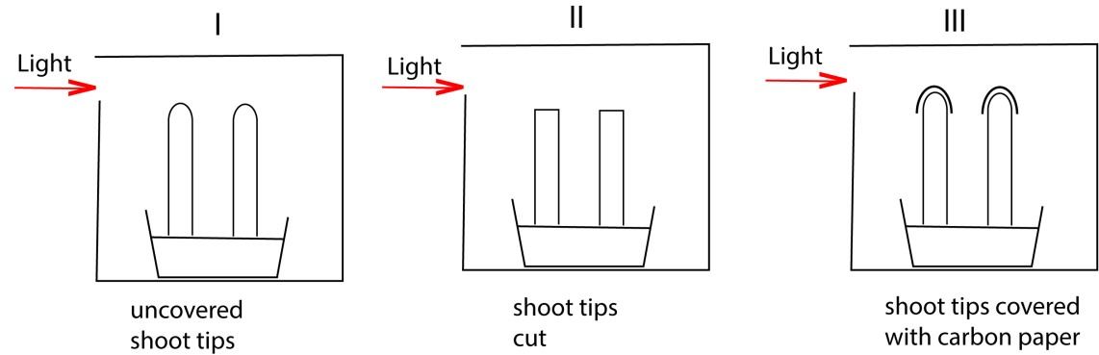
In which experiments would the shoot grow straight?
- I and II
- I and III
- II and III
- III only C
- Which of the following is directional growth response
  - Taxis
  - Reflex
  - Tropic
  - Nastic C
- If a long-day plant has a critical night length of 10 hours, which one of the following conditions would allow flowering in the plant? A. 8 hours light and 16 hours darkness. B. 16 hours light and 8 hours darkness.
  - 12 hours light and 12 hours darkness.
  - 10 hours light and 14 hours darkness. B
Explanation
  - Long-day plants require a night period that is shorter than their critical night length to flower.
  - The critical night length for this plant is 10 hours. This means that if the continuous dark period is 10 hours or longer, flowering will be inhibited.
  - Therefore, for the plant to flower, the night must be less than 10 hours. Option B provides an 8-hour period of darkness, which is shorter than the 10-hour critical night length and thus allows flowering.
- Interruption of the period of darkness by a brief red light prevents flowering in a short day plant because
  - florigen is produced rapidly.
  - the concentration of Pfr lowers.
  - the concentration of Pfr increases.
  - Pr is converted to Pfr. C
Explanation
• Phytochrome System: Plants use a pigment called phytochrome to detect light and measure the length of day and night. Phytochrome exists in two interconvertible forms: o Pr (phytochrome red): The inactive form, which absorbs red light (around 660 nm).
o Pfr (phytochrome far-red): The active form, which absorbs far-red light (around 730 nm).
  - Day-Night Conversion: During the day, red light is abundant, converting most Pr to Pfr. In short-day plants, Pfr acts as a flowering inhibitor. During the continuous darkness of a long night, Pfr is slowly converted back to the inactive Pr form (dark reversion), and its concentration falls to a low enough level to remove the inhibition, thus allowing flowering to occur.
  - Red Light Interruption: When the long dark period is interrupted by a brief flash of red light, the accumulated Pr is immediately converted back into Pfr. This sudden increase in Pfr concentration re-establishes the inhibitory condition, effectively "breaking" the long night signal and preventing the short-day plant from flowering.
Therefore, the increased concentration of Pfr is what inhibits flowering

- The ripening of raw tomatoes when mixed with ripe ones occurs because ripe tomatoes produce.
  - warmth.
  - cytokinins.
  - ethene.
  - Gibberellins C
- The hormone which enables plants to respond to drought is A. gibberellins.
    - abscisic acid.
    - auxins.
    - cytokinin. B
- Which one of the following would occur to a plant requiring at least 14 hours of dark period daily in order to flower?
    - No flowering occurs if the dark period is interrupted with a flash of light.
    - Flowering occurs if the days are 14hours long.
    - No flowering occurs if the dark period is more than 14 days.
    - Flowering occurs if the dark period is interrupted with a flash of light. A
- Ripening of unripe fruits is facilitated when they are enclosed with ripe ones because A. IAA is produced by the ripe fruits to initiate ripening of others.
  - ripe fruits produce ethene which facilitates ripening of others
  - ripe fruits increase the temperature which enhances ripening.
  - the unripe fruits absorb moisture from ripe fruits which speeds up ripening. B
- When the shoot apex of a growing plant is removed, lateral growth is encouraged because A. auxins are activated in buds.
  - growth of lateral buds is stimulated by gibberellins.
  - more abscisic acid is produced to promote lateral growth.
  - cytokinins are activated in the absence of auxins at the apex. A
Explanation
When the shoot apex of a growing plant is removed, lateral growth is encouraged because the source of auxin, a hormone that suppresses lateral bud development, is eliminated.
Specifically, the correct answer is related to the decrease of auxin, but among the given options, the best fit is A. auxins are activated in buds (which should be interpreted as the inhibition from auxins is removed, leading to activation/growth of the buds).
- When are gibberellins formed in the germinating starchy seed?
  - After absorption of water
  - after production of amylase
  - when the radicle immerge
  - during production of amylase A

Explanation
- Water absorption (imbibition): The dry seed takes in water, which causes it to swell and activates the embryo.
- Gibberellin (GA) synthesis: The activated embryo starts to synthesize and release gibberellins.
- Amylase production: The gibberellins diffuse to the aleurone layer of the endosperm, where they signal the de novo synthesis of hydrolytic enzymes, primarily -amylase.
- Starch hydrolysis: α-amylase breaks down the stored starch into simple sugars (glucose and maltose).
- Embryo growth: These sugars are transported to the growing embryo, providing energy for respiration and growth, which eventually leads to the emergence of the radicle.
- Which one of the following pairs of responses in plants is caused by unequal distribution of auxins?
  - Photoperiodism and phototropism.
  - Geotropism and phototropism.
  - Nastic movement and geotropism.
  - Photoperiodism and abscission. B
- The figure below shows the effect of unilateral light on the growth of plant shoots. Study the figure and answer the questions that follow;
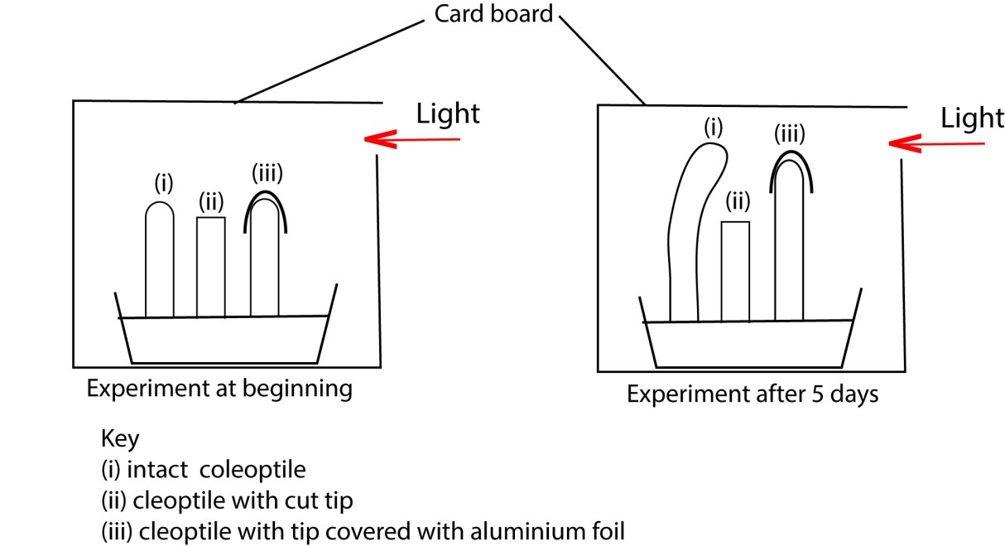
  - Explain why each coleoptile appears as shown after 5 days.
    - presence of tip produces auxins that the concentrate on the dark side of coleoptile and promotes cell elongation more than on the side the receives light causing bending towards light.
    - (did not bend because source of auxins was cut off
    - did not bend because the tip does not produce auxins in absence of light.
  - What is the importance of the response shown in the figure to the plants. (3marks) Phototropism enables the plant to grow towards light to obtain enough light for photosynthesis.
- (a) What is meant by tropism? (02marks)
Tropisms are growth responses towards or away from directional stimuli
(b) Describe the importance of different types of tropisms in plants (13marks)
- Phototropism enables a plant to grow toward and obtain light for photosynthesis.
- Hydrotropism enable plant roots to grow towards and obtain water
- Geotropism is a growth response to gravity: it enable plant roots to grow into the soil to anchor the plant and to obtain water and the shoot to grow upright to receive light.
- Thigmotropism is a response to touch enable the climbing plant to coil around and obtain support from other plants/objects
- Chemotropism plant roots grow towards a region where they can obtain mineral salts and way from dangerous mineral.
- (a) Define
    - phototropism
Phototropism is a growth response of a plant shoot towards light
    - geotropism
This is a growth response of plant shoot and roots in response to gravity. Roots grow toward gravity while shoots grow against gravity
(b) Describe an experiment you would carry out to determine the effects of gravity on the root of a dicotyledonous plant.
    - Two straight soaked bean seedlings with a radial length of about 3cms are selected;
    - One is pinned horizontally straight on a moist board
    - Another is pinned horizontally on another soft board and placed on a vertically rotating clinostat.
    - The experiment is left for three days
Observation
The root of the seedling on clinostat did not bent downward towards gravity while the root of seedling pinned horizontally bent downwards due to uneven distribution of auxins.
- Three healthy, unrelated species of flowering plants A, B and C were subjected to a range different light and dark treatments. The results are shown in the table below.

 | Treatments
Hour of light  Hour of darkness  Species A  B  C | 1  15  9  +  -  + | 2  14  10  +  -  + | 3  13  11  +  -  + | 4  12  12  +  -  + | 5  11  13  -  +  + | 6  10  14  -  +  +

Key: + = flowering, - = no flowering
  - State the photoperiodic group to which each species belong, giving a reason in each case
    - A: long-day plant because decreasing duration of light inhibits flowering.
    - B: short day because decreasing light duration promotes flowering
    - C: day neutral because it is not affected by day light duration
  - Describe how the phytochrome controls flowering response exhibited in species A and B
    - Species A: Pfr promotes flowering since during light Pr is converted to Pfr
    - Species B: Pr promotes flowering since during darkness Pfr is converted to Pr
  - What would be the effect of flashing light during darkness, on each of the specimens?
    - A : flash of light in darkness promote flowering
    - B: flash of light in darkness inhibit flowering
    - C: flash of light in darkness has no effect
- (a) What is meant by apical dominance?
Apical dominance is a phenomenon that occurs in plants where the presence of the apical bud inhibits the growth of lower axillary buds, yet when the epical bud is removed, growth of the lower buds resumes.
(b) State the causes of each of the following
(i) Apical dominance
      - Auxins produced in the apical bud travel down the stem to the lateral buds and inhibit their growth.
      - Presence of the apical bud promotes apical dominance
(ii) Seed dormancy
    - Premature embryo
    - Presence of hard impermeable testa/seed coat.
    - Presence of germination inhibitors such as abscisic acid.
( c) (i) Importance of apical dominance
    - Enable the plant to grow fast vertically so as to access sunlight.
    - Enable the plant to outcompete other individuals in the vicinity for sunlight.
    - In case of damage to the apical bud, it ensures continuity of plant species by allowing the lateral buds to grow thereafter.
(ii). Importance of seed dormancy
    - Enable the seeds to survive unfavorable conditions like drought.
    - Prevents the seeds from developing in the pods
    - Allows for seed dispersal, which ensures colonization of new habitants

- Figure 2 show the effect of red light interruption of night period, on flowering of a plant.
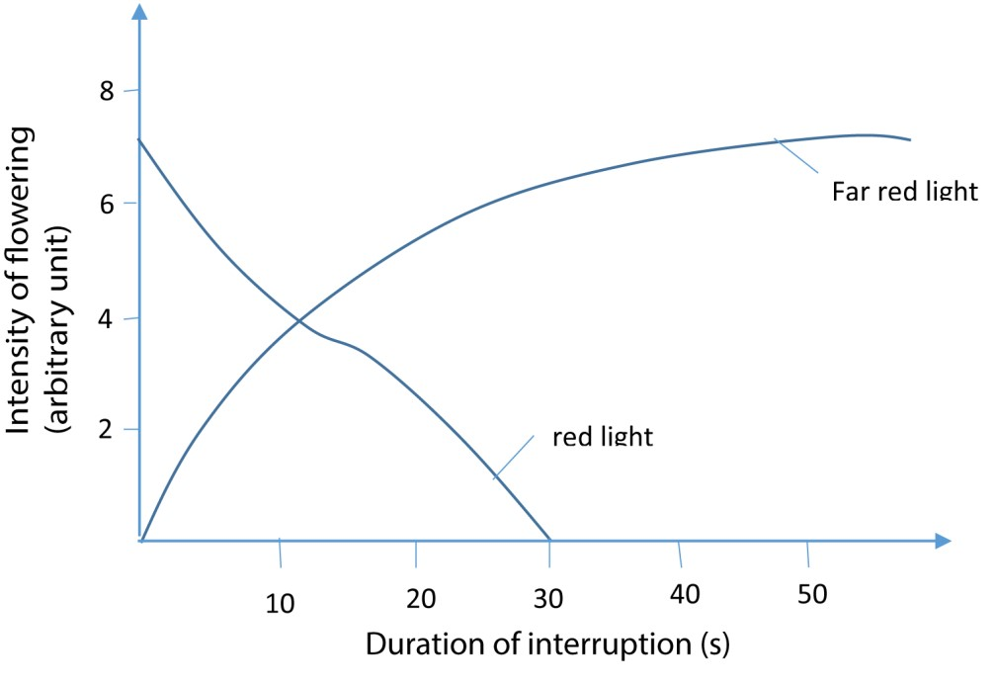
  - What is the effect of interruption of the night period by each type of light?
  - Red light
Generally, exposure to red light inhibits flowering to an extent dependent on the duration of interruption of the night period.
When exposed for 10s or less, red light rapidly reduces intensity of flowering.
Exposed for 10-30s, the intensity of flowering decrease gradually further to zero.
Exposed beyond 30s, flowering does not occurs.
  - Far-red light
Exposure to far red light promotes flowering increasing with the duration of light interruption

  - Suggest the type of plant that would exhibit responses to light treatments as show in figure 2.
Short plant because Pfr promote formation of Pr that promotes flowering in short day.
  - How can the knowledge of the effect of red light and far-red light on flowering be utilized in commercial growing of flowers?
Red light and far-red light stimulate flowering in long day and short- day plants respectively, thus the two types of lights can be used to enhance flower harvest in different plant types.
- An investigation was carried out on the effect of applying different concentrations of auxin on roots and shoots of oat seedlings. The results in table 1 obtained. Were expressed as percentage stimulation (+) or inhibition (-) of growth, compared with untreated controls. Use the information to answer the questions that follow.
Table 1
 |  | Concentration of applied auxins (parts per million)
% simulation of growth. |  | 10-6 | 10-5 | 10-4 | 10-3 | 10-2 | 10-1 | 100 | 101 | 102
% simulation of growth. | Root | +5 | +20 | +20 | +10 | -18 | -55 | -90 | -95 | -98
% simulation of growth. | Shoot | 0 | 0 | 0 | +5 | +20 | 100 | 180 | 150 | 10
  - (i) Present the results in a suitable graphical form. (07 mark)

- Using your graph, describe the effect of different concentrations of auxin on root and shoot growth. (06 marks)
Root growth
  - From 10⁻⁶ to 10⁻⁵ ppm auxin concentration, root growth is stimulated gradually while it is constant between 10⁻⁵ to 10⁻⁴ppm.
  - From 10⁻⁴ to 10⁻³ppm auxin concentration, there is gradual inhibition of root growth followed by rapid inhibition from 10⁻⁰ to 10²ppm.
Shoot growth
  - From 10⁻⁶ to 10⁻⁴ ppm auxin concentration, there is no effect on shoot growth.
  - From 10⁻⁴ to 10⁻²ppm auxin concentration, there is gradual stimulation of shoot growth followed by a rapid stimulation to a maximum from 10⁻² to 10⁰ppm.
  - From 10⁰ to 10²ppm, there is a rapid inhibition of shoot growth.
- From your graph and table 1, point out the difference between the responses of the roots and shoots to the different concentrations of auxin. (04 marks)
Root growth response | Shoot growth response
From 10⁻⁶ to 10⁻⁴ ppm, root growth is stimulated | Auxins concentration from 10⁻⁶ to 10⁻⁴ ppm have no effect on shoot growth.
From 10⁻⁴ to 10⁻³ppm, there is gradual inhibition of root growth. | From 10⁻⁴ to 10⁻²ppm, there is gradual stimulation of shoot growth
From 10⁻² to 10⁰ ppm, there is rapid inhibition of root growth. | From 10⁻² to 10⁰ ppm, there is a rapid stimulation of shoot growth to a maximum.
From 10⁰ to 10²ppm, there is gradual inhibition of root growth | From 10⁰ to 10² ppm, there is a rapid inhibition of shoot growth.
In another experiment, groups of pea seedlings were treated as shown in table 2.
Table 2
Group of seedlings | Treatment done
A | Apical buds removed
B | Apical buds removed and auxin placed on cut stumps.
C | Apical buds removed and Gibberellic acid placed on cut stumps
D | Apical buds removed and cytokinin placed on cut stumps
E | Seedlings left intact
At intervals after treatment, the lengths of the axillary shots were determined and the results obtained were recorded as shown in table 3.
Table 3
Time after start of treatment  (days) | Mean total axillary shoot length per group of seedlings (mm)
Time after start of treatment  (days) | A | B | C | D | E
2 | 3 | 3 | 3 | 3 | 3
4 | 10 | 4 | 12 | 9 | 3
6 | 30 | 4 | 45 | 32 | 3
8 | 50 | 5 | 90 | 47 | 3
10 | 78 | 6 | 116 | 80 | 3
13 | 118 | 30 | 150 | 119 | 3

i. What was the effect of the treatment done, on each group of seedlings at the end of the experiment?

Group A: There is gradual increase in mean total axillary shoot length with time up to day 10 followed by a rapid increase up to day 13
Group B: There is a very slow increase in mean total axillary shoot length with time up to day 10 followed by a rapid increase up to day 13.
Group C: There is rapid increase in mean total axillary shoot length with time up to day 8 followed by a more rapid increase up to day 13.
Group D: There is a gradual increase in mean total axillar shoot length with time up to day 4 followed by a rapid increase up to day 10 and a more rapid increase up to day 13.
Group E: Mean total axillary shoot length remains constant over the period of the experiment.
ii. Explain the results in table 3.
Group A: removal of apical bud promotes growth of lateral shoot because the source of auxins is removed since auxins that inhibit development of lateral shoot.
Group B: development of lateral shoot is inhibited by presence of auxins
Group C: development of lateral shoots is promoted by absence of auxins and presence of gibberellins.
Group D: development of lateral shoots is promoted by absence of apical buds(source of auxins) and cytokinins have no effect.
Group E: development of lateral shoots is inhibited by auxins from apical buds

iii. Outline ways in which auxins have been used in improving agriculture.
- Selective weed control: Synthetic auxins like 2,4-D are used as herbicides to eliminate broadleaf weeds without harming grasses
- Root formation in cuttings: Auxins stimulate root development in plant cuttings, improving propagation success for crops like sugarcane and tomatoes.
- Apical dominance: They suppress lateral bud growth, allowing farmers to control plant shape and encourage upward growth.
- Cell elongation and division: Auxins promote elongation and division, leading to healthier and more vigorous plants
- Induction of parthenocarpy: Auxins help produce seedless fruits such as tomatoes and bananas, which are often preferred in markets.
- Flowering stimulation: In crops like pineapple, auxins are used to synchronize flowering, aiding in uniform harvesting.
- Control of fruit set and drop: They regulate fruit development and prevent premature fruit drop, improving yield consistency

Revision exercise on coordination in animals
- Onset of depolarization of an axon occurs when the axoplasm temporarily become
  - more negative
  - less negative
  - more positive
  - less positive B
Explanation
  - Resting Potential: In a resting neuron, the inside of the axon (axoplasm) is negatively charged relative to the outside (approximately -70 mV).
  - Depolarization: A stimulus causes voltage-gated sodium channels to open, allowing positively charged sodium ions (Na⁺) to rush into the cell.
  - Change in Charge: This influx of positive ions makes the inside of the membrane less negative, and if the stimulus is strong enough to reach the threshold, the inside even becomes positively charged (around +30 mV).
  - Result: The change from a negative charge towards zero or a positive charge means the axoplasm becomes less negative compared to its resting state.
- Wearing a coarse shirt causes a tickling sensation but the sensation disappears. Which of the following is not explanation of this observation?
  - Supply of transmitter substances get exhausted
  - The discharge of impulses at afferent nerve ceases
  - The membrane surrounding the generator region becomes less permeable to sodium ions
  - Generator potential falls below threshold values C
Explanation
• Sensory Adaptation: Sensory adaptation is the phenomenon where a sensory receptor's response to a constant stimulus decreases over time. The tickling sensation from a coarse shirt fading away is a classic example of this.
Options (A, B, D) are all direct or indirect consequences of the adaptation process, while option C describes a cellular mechanism that is a cause, not an effect, of the adaptation.

- Which of the following occurs when the axon is depolarized?
    - Sodium enters the axon, potassium leave
    - Both sodium and potassium ions leave the axon
    - Potassium enter the axon and sodium leave
    - Both sodium and potassium ions enter the axon A

Explanation
  - The depolarization phase of an action potential begins when a stimulus causes voltagegated sodium channels to open.
  - Due to the high concentration of sodium ions outside the axon and the negative charge inside, sodium ions (Na⁺) rapidly rush into the axon. This influx of positive ions causes the membrane potential to become less negative, and eventually positive.
  - During this depolarization phase, the voltage-gated potassium channels remain closed, preventing potassium ions from leaving the cell. The outflow of potassium ions only occurs later during the repolarization phase.

- A person who walks unsteadily may have a defect in the
  - Cerebrum
  - Cerebellum
  - Medulla oblongata
  - Hypothalamus B

Explanation
  - Cerebellum: The cerebellum, often called the "little brain," is located at the back of the brain, below the cerebrum and behind the brainstem. Its primary functions include coordinating voluntary movements, maintaining balance and posture, and ensuring smooth, accurate muscular activity. Damage to the cerebellum is a common cause of ataxia, a condition characterized by uncoordinated and unsteady movements, including an unsteady gait.
  - Cerebrum: The cerebrum is the largest part of the brain, responsible for higher functions like thinking, reasoning, emotion, memory, and initiating voluntary movements. While it starts the movement signal, it relies on the cerebellum to fine-tune and coordinate it.
  - Medulla Oblongata: The medulla oblongata is part of the brainstem and controls essential involuntary functions necessary for survival, such as heart rate, breathing, and blood pressure, as well as reflexes like swallowing, coughing, and vomiting.
  - Hypothalamus: The hypothalamus is mainly involved in regulating bodily functions like thirst, hunger, sleep patterns, and body temperature. It also links the nervous system to the endocrine system via the pituitary gland.
Therefore, a defect resulting in unsteadiness and difficulty with balance would point to the cerebellum.

- Which one of the following describes the sodium-potassium pump?
  - Active pumping potassium ion out of the axon and sodium ions into it.
  - Equal concentration of the ions on either side of the axon when at rest
  - Inability of the axon to absorb the two ions passively
  - Active pumping sodium ion out of the axon and potassium ions into it. D

Explanation
  - The sodium-potassium pump is a protein that uses energy from ATP to move ions against their concentration gradients.
  - Its specific function is to pump three sodium ions (Na⁺) out of the cell and two potassium ions (K⁺) into the cell during each cycle.
  - This active transport mechanism is crucial for maintaining the resting membrane potential of neurons, as it keeps a high concentration of sodium outside the axon and a high concentration of potassium inside.
- Which one of the following is not a transmitter substance?
  - Acetylcholine
  - Cholinesterase
  - Atropine
  - Noradrenaline B
* Cholinesterase is an enzyme that inactivates Acetylcholine
- The principle function of the autonomic nervous system is to
  - Innervate the internal organs
  - Control the contraction of skeletal muscles.
  - Regulate and control the peripheral nervous system
  - Transmit impulses from the brain to the central nervous system A
- Which of the following represent the correct order of events that occurs at the synapse during impulse transmission?
  - Ca²⁺ ion influx, release of transmitter substances, depolarization
  - Depolarization, release of transmitter substance, Ca²⁺ ion influx
  - Release of transmitter substances, Ca²⁺ ion influx, depolarization
  - Release of transmitter substances, depolarization, Ca²⁺ ion influx A

- A likely effect of inhibiting the action of acetylcholinesterase at a synapse is
  - Cessation of impulse transmission
  - Speeding up of impulse transmission
  - Continuous impulse transmission
  - Slowing down of impulse transmission C

Explanation
  - Normal Synaptic Function: Acetylcholinesterase (AChE) is an enzyme responsible for rapidly breaking down the neurotransmitter acetylcholine (ACh) in the synaptic cleft. This rapid degradation is crucial for ensuring that the signal transmission is brief and that the postsynaptic membrane can repolarize and be ready to receive a new signal.
  - Inhibiting AChE: When the action of AChE is inhibited, acetylcholine accumulates in the synaptic cleft and continues to bind to the receptors on the postsynaptic membrane.
  - Continuous Transmission: This prolonged binding results in continuous stimulation of the postsynaptic neuron or effector organ (like a muscle), leading to continuous impulse transmission or continuous muscle contraction (spasms).

- Which one of the following occurs to the axon membrane during an action potential? It is
  - Polarized with inside negative outside positive
  - Depolarized with inside negative while outside positive C. Depolarized with inside positive while outside negative
D. Polarized with inside positive while outside negative C

- Myelinated axons of a frog conduct impulses three times less fast as those of the same diameter in rat because the
  - Myelin sheath in axons of frogs are thinner
  - Rats are endothermic
  - Neuron of a frog have more synapses
  - Frog lives in water which is cold B
- Increased permeability of the post synaptic membrane to allow chloride ion in, and potassium ions out of the cell causes
  - Depolarization of the cell membrane
  - Polarization of the membrane
  - Excitation of the membrane
  - Hyper polarization of the membrane D
Explanation
  - Resting Potential: In a resting neuron, the inside of the cell is relatively negative compared to the outside (polarized state).
  - Ion Movement:
o Chloride ions (Cl⁻) in: Chloride ions carry a negative charge. Their movement into the cell makes the inside even more negative. o Potassium ions (K⁺) out: Potassium ions carry a positive charge. Their movement out of the cell removes positive charges from the inside, also making the inside more negative.
  - Hyperpolarization: Both of these movements (negative ions in, positive ions out) increase the negative charge inside the cell beyond its normal resting potential. This state of increased negative charge is called hyperpolarization.
  - Inhibitory Postsynaptic Potential (IPSP): Hyperpolarization makes the postsynaptic neuron less likely to reach the threshold for generating an action potential. This effect is inhibitory.
- After an action potential, repolarization of the membrane begins by
  - Entry of sodium into the cell
  - Sodium ion diffusing out of the cell
  - Entry of potassium ions into the cell
  - Potassium ions diffusing out the cell D

Explanation
Here is a summary of the action potential events:
  - Depolarization: Sodium channels open, and sodium ions (

Na+Na raised to the positive power
Na+
) rush into the cell, making the inside positive.
  - Peak of Action Potential: The positive charge inside triggers the sodium channels to close.
  - Repolarization: Voltage-gated potassium channels open, and because the concentration of potassium ions (K⁺) is much higher inside the cell, they rapidly diffuse
out of the axon. The movement of positive charges out of the cell restores the negative charge inside the membrane.
  - Hyperpolarization (Undershoot): The potassium channels close slowly, leading to a brief period where the inside is even more negative than the resting potential.
  - Resting Potential Restoration: The sodium-potassium pump works to re-establish the correct ion distribution across the membrane.
Therefore, the outward diffusion of potassium ions is the event that initiates repolarization.

- Wearing a coarse shirt cause unpleasant sensation at first but latter the discomfort disappears because
  - With continued stimulus, generator falls below threshold value
  - The post synaptic surface fails to release the transmitter substance
  - Nervous system stops carrying sensory impulse
  - Continued stimulation leads to fusion of generator potential A

- Which one of the following is the correct statement about a neuron membrane during resting potential?
  - The inside of neuron membrane is negatively charged
  - The Na⁺, K⁺ and Cl⁻ ions are evenly distributed on either side of the membrane
  - The concentration of Na⁺ ions is greater inside the membrane
  - The concentration of K⁺ is greater outside the membrane A
Explanation
  - The resting potential of a neuron is the electrical charge difference across the membrane when the neuron is not transmitting an impulse. This potential is typically around -70 millivolts, with the minus sign indicating that the inside of the cell is negatively charged relative to the outside.
  - This negative charge is maintained primarily by the active transport of ions via the sodium-potassium pump, which moves three sodium ions (Na+) out of the cell for every two potassium ions (K+) it pumps in. This creates a high concentration of Na+ outside the cell and a high concentration of K+ inside. Additionally, the membrane is more permeable to potassium ions at rest, allowing some K⁺ to leak out, further contributing to the negative charge inside.
- Which one of the following describes the state of the membrane during resting potential?
  - Polarized
  - Neutral
  - Depolarized
  - Discharged A

- Which one of the following is correct about the sympathetic nervous system?
    - Nerve endings produce noradrenaline
    - Preganglionic fibres are long and post ganglionic fibres are short
    - Nerve endings produce acetylcholine
    - Ganglia are embedded in the walls of the effector A
- The figure below shows changes in electrical potentials in an axon membrane when an impulse is transmitted.
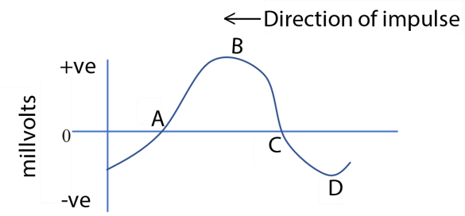
At which stage of the electrical potential marked, is the axon most permeable to sodium? A
- Impulse crosses a synapse by means of
  - Sodium ions
  - Potassium ions
  - Calcium ions
  - Neurotransmitter chemicals (acetylcholine or noradrenaline) D
- Impulse transmission in mammals is usually faster in mammals than it is in amphibians because
  - Axons of amphibians lack myelin sheath
  - Mammals have axons with larger diameter
  - Mammals usually have high body temperature
  - The distance between the node of Ranvier in mammals is short C

Explanation
Impulse transmission in mammals is usually faster than in amphibians for two primary reasons related to evolutionary adaptations for speed:
  - Mammals usually have high body temperature: Mammals are homeotherms (warmblooded) and maintain a high, constant body temperature. Higher temperatures increase the kinetic energy of ions, leading to faster opening and closing of ion channels and quicker action potential generation and conduction velocity. Amphibians are poikilotherms (cold-blooded), and their nerve conduction speed is dependent on the ambient temperature, which is often lower than the mammalian body temperature.
  - Myelination: While not an explicit option in the list as phrased, myelination is a key factor. Both mammals and amphibians have myelinated axons, but mammalian nerve fibers are generally more extensively and effectively myelinated, allowing for more efficient saltatory conduction (nerve impulses "jumping" from node to node). This significantly increases speed compared to unmyelinated fibers or less effectively myelinated ones.

- Which one of the following would occur at the onset of an action potential in a neuron?
  - Potassium ions enter
  - Sodium ion leave
  - Potassium ion leave
  - Sodium ion enter D

- Which one of the following is caused by a high concentration of sodium ions outside the neuron?
  - Production of successive action potentials
  - Excitation of the neuron
  - Inhibition of the release of the transmitter substance
  - Polarization of the neuron D

Explanation
  - Polarization refers to the resting state of the neuron, where there is an electrical potential difference across the cell membrane.
  - At rest, the inside of the neuron is negatively charged relative to the outside. This is maintained by the sodium-potassium pump, which actively transports three sodium ions (Na⁺) out of the axon for every two potassium ions (K⁺) it pumps in.
  - This action creates and maintains a high concentration of sodium ions outside the neuron and a high concentration of potassium ions inside the neuron, which is the very definition of the neuron's polarized or resting state

23 Which one of the following does not happen when an impulse reaches a synapse?
- Facilitating passage of subsequent impulses
- Being blocked
- Being reversed
- Inhibiting passage of subsequent impulses C

Explanation
Synaptic Transmission is Unidirectional: Nerve impulses travel in only one direction across a synapse, from the presynaptic neuron to the postsynaptic neuron. This is because neurotransmitters are released only from the presynaptic terminal, and the receptors for these neurotransmitters are located exclusively on the postsynaptic membrane. Therefore, the signal cannot be reversed.
- During an action potential in a neuron,
  - Potassium ions diffuse into the axon
  - Sodium ions diffuse out of the axon
  - Sodium ions diffuse into the axon
  - Both sodium and potassium diffuse out C

- Which one of the following statement is true only of sympathetic nervous system?
  - Nerve endings produce noradrenaline
  - Preganglionic fibers are short
  - Nerve ending produce acetylcholine
  - Preganglionic fibers are long A 26. Injection of thyroxine into laboratory mammal would cause
  - Oxygen consumption to increase
  - Metabolic rate to decrease
  - Conversion of glucose into glycogen
  - Thyroid gland to become more active A
Explanation
Thyroxine is the main hormone produced by the thyroid gland and plays a vital role in regulating metabolism across nearly all cells in the body.
  - Increased Oxygen Consumption and Metabolic Rate: Thyroxine stimulates the basal metabolic rate (BMR), which involves increasing the speed at which cells use oxygen and food products to release energy (heat production). An injection of thyroxine into a mammal typically results in a state similar to hyperthyroidism, leading to an elevated metabolic rate and increased oxygen consumption.
  - Other effects: The increased metabolic activity makes more glucose available to cells through glycogenolysis and gluconeogenesis, it stimulates protein synthesis (though high doses can cause catabolism), and increases lipid metabolism.

27 Wearing a coarse shirt, a tickling causes sensation but later the sensation disappears. Which one of the following is not an explanation of this observation?
- Supply of transmitter substances get exhausted
- Discharge of impulses of afferent nerve ceases
- The membrane surrounding the generator region become less permeable to sodium ions
- Generator potential falls below threshold value C 28. Which one of the following occurs when the axon membrane depolarizes?
- Sodium ion enters the axon and potassium leave
- Both sodium and potassium ions leave the axon
- Potassium enter the axon and sodium leave
- Both sodium and potassium ions enter the axon A
- A mother, who lacked milk in her breasts at the birth of her baby was diagonized to have a brain damage. Which of the following parts of the brain is most likely to have been affected?
  - Posterior lobe of the pituitary gland
  - Pineal body
  - Anterior lobe of pituitary gland
  - Cerebrum C
Explanation
The mother's inability to produce milk at the birth of her baby, potentially due to brain damage, suggests a problem with the hormones responsible for milk production and release.
  - Prolactin, the hormone primarily responsible for producing milk, is secreted by the anterior lobe of the pituitary gland. After childbirth, the drop in progesterone and estrogen allows prolactin to initiate milk secretion.
  - Oxytocin is responsible for the "let-down" reflex, which ejects the milk from the breasts, and is released from the posterior lobe of the pituitary gland (though synthesized in the hypothalamus).
  - Damage to the pituitary gland, a condition known as hypopituitarism or Sheehan's Syndrome (following severe blood loss during birth), can affect the secretion of these hormones and lead to a lack of breast milk.
Therefore, the part of the brain most likely affected is the anterior lobe of the pituitary gland, which controls milk production. The correct option is C.

- Which one of the following is not a transmitter substance?
  - Acetylcholine
  - Cholinesterase
  - Atropine
  - Noradrenaline B 31. The myelin sheath and the diameter of the axon of a neuron are important in that they
  - Enable impulses to be transmitted from one node of Ranvier to another
  - Increase the speed at which impulses are transmitted
  - Maintain a constant strength of each impulse
  - Allow quick exchange of ions B 32. Which one of the following is correct about the refractory period in an axon of a nerve fibre?
  - Inhibitory postsynaptic potentials are generated
  - Voltage activated sodium channel open
  - The axon cannot transmit impulses
  - The axon can transmit impulses at higher voltage C
Explanation why D is incorrect
The refractory period is a time when the axon's excitability is decreased. In the absolute refractory period, no impulse can be transmitted at all. In the relative refractory period, a new impulse can be generated, but it requires a stronger stimulus, not a higher voltage from the axon itself.

33. Which one of the following describes the sodium-potassium pump?
- Active pumping of potassium out of an axon and sodium into it.
- Equal concentration of the ions on either side of the axon when at rest
- Inability of the axon to absorb the two ions passively
- Active pumping of sodium ions out of the axon and potassium into it D 34. Which one of the following occurs when the axon membrane depolarizes?
- Sodium ions enter the axon and potassium ion leave
- Both sodium and potassium ions leave the axon
- Potassium ions enter the axon and sodium ion leave
- Both sodium and potassium ion enter the axon A
- Which one of the following would be the best indicator that a cell is responding to a hormone?
  - High concentration of cyclic AMP
  - Low concentration of AMP in cell
  - Low concentration of adenyl cyclase in the cell
  - High amount of ATP in the cell A
Explanation
  - Many hormones, particularly water-soluble ones like adrenaline and glucagon, cannot pass through the cell membrane. Instead, they bind to specific receptors on the cell surface.
  - This binding event triggers a signal transduction cascade inside the cell, often involving a G-protein and an enzyme called adenylyl cyclase.
  - Activated adenylyl cyclase catalyzes the conversion of ATP into a molecule called cyclic AMP (cAMP).
  - Cyclic AMP acts as a "second messenger" to relay the hormone's signal from the cell membrane to the interior of the cell. A high concentration of cAMP is a key indicator that a hormone has successfully bound to its receptor and initiated a cellular response.

- A person who walks unsteadily may have a defect in the
  - Cerebrum
  - Cerebellum
  - Medulla oblongata
  - Hypothalamus B

Structured questions
- (a) Give one function of synapse (01mark)
    - Signal transmission: Synapses allow nerve impulses to pass from one neuron to another or to a muscle/gland cell.
    - Neurotransmitter release: When an impulse reaches the presynaptic terminal, neurotransmitters are released into the synaptic cleft.
    - Receptor activation: These neurotransmitters bind to receptors on the postsynaptic membrane, triggering a response in the next cell.
    - Directionality of impulse: Synapses ensure one-way transmission of impulses, maintaining organized neural communication.
    - Integration of signals: Synapses help neurons process multiple inputs, allowing complex decision-making and coordination.
    - Plasticity and learning: Synaptic strength can change over time, forming the basis of learning and memory.
    - Signal Termination: Synapses have mechanisms to quickly terminate the signal (e.g., enzymatic breakdown, reuptake, diffusion) to ensure the postsynaptic cell can return to its resting state and respond to new signals efficiently.
    - Excitation and Inhibition: Synapses can be either excitatory (making the postsynaptic neuron more likely to fire an action potential) or inhibitory (making it less likely to fire). This allows for complex neural circuits and control over bodily responses
(b) When an action potential arrives at the synapse, calcium ions enters the neuron through presynaptic membrane.
(i) Explain how the calcium ions enter the neuron (02marks)
When an action potential reaches the presynaptic terminal:
    - Voltage-gated calcium channels in the presynaptic membrane open due to depolarization.
    - Calcium ions (Ca²⁺) enter the neuron by diffusing down their electrochemical gradient from the extracellular fluid into the cytoplasm of the presynaptic terminal.
(ii) Describe the events which occur as a result of the entry of the calcium ions to cause depolarization of the post synaptic membrane. (05marks)

Events following calcium entry leading to postsynaptic depolarization
- Synaptic vesicle fusion: Calcium ions bind to proteins on synaptic vesicles, triggering their fusion with the presynaptic membrane.
- Neurotransmitter release: Vesicles release neurotransmitters (e.g., acetylcholine) into the synaptic cleft via exocytosis.
- Binding to receptors: Neurotransmitters diffuse across the cleft and bind to ligand-gated ion channels on the postsynaptic membrane.
- Ion influx: This causes the channels to open, allowing sodium ions (Na⁺) to enter the postsynaptic neuron.
- Depolarization: The influx of Na⁺ reduces the membrane potential, leading to depolarization of the postsynaptic membrane, which may initiate a new action potential.

. 38. The figure below shows the variation of a nerve impulse conduction speed with total diameter, of myelinated and non-myelinated fibres
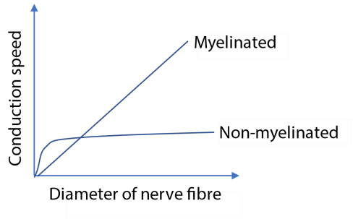

- Compare the variation of the speed of conduction with the diameter in the two types of fibres (4marks)
In both myelinated fibre, the conduction speed increases with increase in the diameter of the nerve fibre.
In myelinated fibre; the conduction speed increases linearly with increase in the diameter of the nerve fibre while in non-myelinated fibre the increase is non-linear
Increase in the diameter of the nerve fibre beyond 1 arbitrary unit still causes a steep linear increase in the conduction speed in myelinated fibre while the conduction speed in non –myelinated fibre remain almost constant.

- Explain the difference in the conduction speed of the two fibres (2marks) Myelinated fibres are surrounded by myelin sheath (with high electrical resistant) which is interrupted at intervals by nodes of Ranvier (with low electrical resistance). Thus during impulse transmission, depolarization only occurs at nodes of Ranvier. This mean the action potential leaps from node to node thereby speeding up impulse conduction.
- Suggest the significance of the transmission speed in nervous communication. (4marks)
  - Rapid response to stimuli Enables organisms to detect and respond quickly to environmental changes or threats, enhancing survival (e.g., pulling away from a hot object).
  - Efficient coordination of body functions: Fast transmission ensures that muscles and organs receive timely signals, allowing smooth and synchronized movements (e.g., walking, speaking).
  - Precise control of complex processes: High-speed communication is essential for tasks requiring fine motor skills and coordination, such as writing or playing an instrument.
  - Minimization of reaction time: In reflex actions, fast transmission reduces the time between stimulus and response, protecting the body from harm.
  - Support for higher cognitive functions: Quick signal transmission between brain regions supports thinking, learning, memory, and decision-making processes. 39. (a) In the space below, draw a labeled structure of synapse (04marks)
(b) How does an impulse cross a synapse? (06marks)
Arrival of an impulse at the synaptic causes an influx of Ca²⁺ ions into the knob from the synaptic cleft.
- The Ca²⁺ ion causes the synaptic vesicles to move towards the pre-synaptic membrane.
- The vesicles fuse with the pre- synaptic membrane and release a transmitter substance into the synaptic cleft by exocytosis.
- The transmitter substance diffuses across the synaptic cleft and attaches to specific receptor sites on the post synaptic membrane.
- This causes an influx of Na⁺ ion into post- synaptic membrane, resulting in local depolarization of the membrane. If the Na⁺ ion surge is large enough, an action potential (impulse) is generated in the post –synaptic neuron.
- The figure shows dendrites from neurons A and B forming synapse with neuron C



Acetylcholine

A B

X

C

  - Explain what would happen if
    - Acetyl choline increased the permeability of the post synaptic membrane to Na⁺ ions. (3marks)
Na⁺ ions would move into the neuron C causing membrane depolarization. If the Na⁺ ions surge into the neuron C is large enough, an action potential is generated in neuron C and an impulse is eventually transmitted from A and C.
    - X increased the permeability of the post synaptic membrane to Cl⁻ ions
(3marks)
CI⁻ ions would move into neuron C making the membrane potential more negative. If the CI⁻ surge is large enough, hyperpolarization would prevent action potential to be elicited in C. This prevents transmission of an impulse from B to C
  - State a benefit of neuron C forming synapses with two neurons a and B. (1marks) It allows selective transmission of impulses to neuron C; A facilitating transmission while B inhibiting it.
  - State three function of synapse. (3marks)
    - They facilitate transmission of impulses from one neuron to another.
    - They may inhibit transmission of certain impulses from one neuron to another.
    - They control the transmission of impulses from neuron in the nervous system.
    - They allow for summation of impulses.
- The figure 3 shows changes in an axon as an impulse passes along the axon.

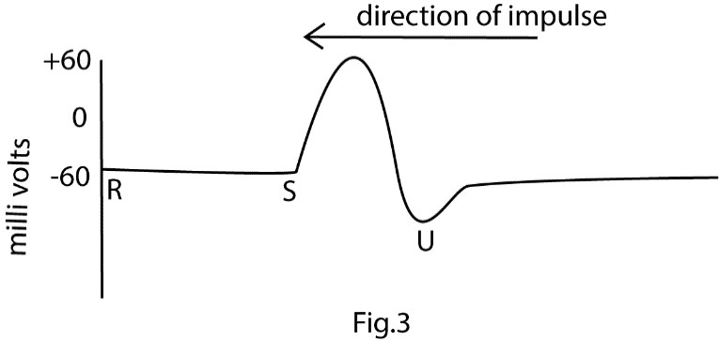
T

  - What is the state of the axon membrane between
    - R and S (01mark) membrane polarized S and T (01mark) membrane depolarized
  - Describe the movement of ions across the axon membrane between
    - R and S (2marks)
Sodium ions move out the cell while potassium ion move into of the cell actively against their concentration gradient by potassium/sodium pump.
    - S and T
Sodium channel open and sodium ion diffuse into axon causing depolarization.
    - T and U
Potassium gates open potassium ions diffuse out of axoplasm to polarise the membrane. Sodium gates close and permeability to sodium ions close.
  - Why is it diffucult to stimulate an axon shortly after it has transmitted an impulse?
(02marks)
    - During absolute refractory period, Voltage-gated sodium channels are inactivated and cannot reopen no matter how strong the stimulus, thus the axon cannot generate another action potential.
    - During Relative refractory period, the membrane is (hyperpolarized that a stronger-than-normal stimulus is required to trigger another action potential.

- The figure shows the result of one end of axono being stimilated with six electrical shocks of gradually increasing intensity and its response from other end. Study the figure and answer the following questions


A

B

C

Axon

magnitude

Stimuli

Action
potential

- Describe the behavior of the axon in the regions labelled A, B,and C in relation to the magnitude of the stimulus given
Region A: polarised

Region B: depolarised

Region C: repolarising
- What principle does the behavior of the axon illustrate?
The All-or-None Law i.e. once a stimulus reaches the threshold level, a neuron or muscle fiber will respond with a full action potential or contraction. If the stimulus is below threshold, no response occurs at all.
- What determines the speed at which an impulse it transmitted along an axon?

Factor | Effect on Speed
Myelination | Increases speed significantly. Myelinated axons use saltatory conduction, where impulses jump between nodes of Ranvier, bypassing insulated regions.
Axon Diameter | Larger diameter = faster conduction. Wider axons offer less resistance to ion flow, allowing quicker depolarization.
Temperature | Higher temperature = faster impulse. Increased kinetic energy enhances ion movement and enzyme activity. However, extreme heat can denature proteins and impair conduction

- what is the advantage to an organism of having its impulse transmitted rapidly?

  - Rapid response to stimuli Enables organisms to detect and respond quickly to environmental changes or threats, enhancing survival (e.g., pulling away from a hot object).
  - Efficient coordination of body functions: Fast transmission ensures that muscles and organs receive timely signals, allowing smooth and synchronized movements (e.g., walking, speaking).
  - Precise control of complex processes: High-speed communication is essential for tasks requiring fine motor skills and coordination, such as writing or playing an instrument.
  - Minimization of reaction time: In reflex actions, fast transmission reduces the time between stimulus and response, protecting the body from harm.
  - Support for higher cognitive functions: Quick signal transmission between brain regions supports thinking, learning, memory, and decision-making processes.
Assay question
43. (a) Draw a fully labelled diagram of a neurotransmitter junction

(b) Explain how the impulse are transmitted across the junction in (a) above

- Arrival of impulse causes the calcium voltage gates to open leading to influx of
calcium ions from the synaptic cleft.
- The Ca²⁺ ion causes the synaptic vesicles to move towards the pre-synaptic membrane.
- The vesicles fuse with the pre- synaptic membrane and release a transmitter substance into the synaptic cleft by exocytosis.
- The transmitter substance diffuses across the synaptic cleft and attaches to specific receptor sites on the post synaptic membrane.
- This causes an influx of Na⁺ ion into post- synaptic membrane, resulting in local depolarization of the membrane. If the Na⁺ ion surge is large enough, an action potential (impulse) is generated in the post –synaptic neuron.
- How is the transmission across the synapse controlled?
  - Neurotransmitter release regulation: The amount of neurotransmitter released depends on calcium ion influx into the presynaptic terminal. More calcium = more vesicle fusion = stronger signal.
  - Availability of Neurotransmitters: The synthesis, storage in vesicles, and transport of neurotransmitters are regulated processes. The rate at which vesicles are refilled and made available in the "readily releasable pool" influences how strongly a synapse can respond to sustained activity.
  - Presynaptic Modulation (Axoaxonic Synapses): Some synapses form on the axon terminals of other neurons (axoaxonic synapses). These can regulate the amount of neurotransmitter released by the second neuron, either increasing (facilitation) or decreasing (inhibition) its effect on the postsynaptic cell.
  - Autoreceptors: Receptors on the presynaptic membrane (autoreceptors) can detect the amount of neurotransmitter that has been released. If the concentration is too high, they can trigger a negative feedback loop to reduce further release.
  - Enzymatic breakdown of neurotransmitters: Enzymes like acetylcholinesterase break down neurotransmitters (e.g., acetylcholine) in the synaptic cleft, stopping the signal.
  - Reuptake by presynaptic neuron: Neurotransmitters like serotonin and dopamine are reabsorbed into the presynaptic neuron via transporter proteins, reducing their effect.
  - Diffusion away from the synaptic cleft: Some neurotransmitter molecules diffuse out of the cleft, lowering their concentration and impact.
  - Inhibitory neurotransmitters: Neurotransmitters like GABA cause hyperpolarization of the postsynaptic membrane, making it less likely to fire.
  - Desensitization of receptors: Continuous stimulation can lead to receptor desensitization, reducing responsiveness to neurotransmitters.

44. (a) Explain the following processes involved in transmission of impulses along a neuron
(i) The formation of the resting potential
A nerve cell when at rest, it membrane inside is negatively than on the outside by a potential difference about -70mV.
The resting membrane potential is maintained by sodium potassium pumps found in the cell's membrane. These use energy in form of ATP to actively pump 3 Sodium ions out of the cell for every 2 Potassium ions inside the cell. (ii) The formation and transmission of an action potential
An impulse or action potential is a temporary and local reversal of the resting membrane potential, arising when an axon is stimulated. Information is transmitted through the nervous system as a series of impulse which travel as action potential.
(b) How does a retina transduce light energy into a nerve impulse
    - The retina has photoreceptor cell, the cone and rod that contain photopigment called rhodopsin
    - Rhodopsin contains a protein called opsin and a light sensitive molecule or chromophore; retinal an aldehyde of vitamin A.
    - When retinal is struck by light, retinal changes from cis to trans form. the change triggers electrical impulse to the brain (iv) Retinal in cis form it then regenerated.

- What determines the speed at which an impulse is transmitted along the axon?

Factor | Effect on Speed
Myelination | Increases speed significantly. Myelinated axons use saltatory conduction, where impulses jump between nodes of Ranvier, bypassing insulated regions.
Axon Diameter | Larger diameter = faster conduction. Wider axons offer less resistance to ion flow, allowing quicker depolarization.
Temperature | Higher temperature = faster impulse. Increased kinetic energy enhances ion movement and enzyme activity. However, extreme heat can denature proteins and impair conduction

Revision questions on receptors, eyes and ears
1. Cones have better visual acuity than rods because cones
- have little retinal convergence
- are more sensitive to light
- connect with a single optic fibre
- are more concentrated at the fovea C
Explanation
Cones have better visual acuity than rods primarily because of their neural connectivity and their concentration in the fovea. The most accurate options reflecting this are:
A. have little retinal convergence
C. connect with a single optic fibre (which is effectively the same as little/no retinal convergence in the central fovea)
In the central fovea, where visual acuity is highest, each cone often has a dedicated pathway, connecting to a single bipolar cell, which in turn connects to a single retinal ganglion cell (optic nerve fiber pathway). This one-to-one or very low convergence pathway preserves spatial information, allowing the brain to pinpoint the exact location of a light stimulus and distinguish between two closely positioned points (high resolution).
In contrast, multiple rods (many-to-one) converge onto a single bipolar cell and ganglion cell in the peripheral retina. This pooling of signals increases overall light sensitivity (good for low light, which relates to option B being a property of rods, not cones), but it significantly reduces spatial resolution or acuity.
Option D is a location characteristic that enables the high acuity due to options A and C's wiring, but the direct reason related to signal processing is the lack of convergence.
Both A and C are strong, related explanations, but A is the more general principle, while C describes the specific neural pathway in the fovea

- Which one of the following is true of what occurs at the excitatory synapse when impulse arrives?
  - chloride channels close
  - receptor site close
  - post synaptic membrane becomes impermeable to calcium ions
  - Sodium ion channels open D
*An excitatory synapse works to depolarize the postsynaptic membrane, making the neuron more likely to fire an action potential.

- In the mammalian eye, rods have a poorer visual acuity than cones because they are
- fewer in number
- smaller in size
- connected to more than one optic nerve
- less sensitive to light C
Explanation:
- Rods have poorer visual acuity because multiple rods synapse with a single bipolar neuron, which then connects to the optic nerve.
- This convergent wiring means the brain receives a combined signal from many rods, reducing the ability to distinguish fine detail.
- In contrast, cones often have a one-to-one connection with bipolar cells, allowing for high-resolution vision.
- Staying in a dark room for a long tine increases the sensitivity of the eye to light because photochemical pigment are
  - Not broken down
  - Formed faster than they are broken down
  - Destroyed
  - Not synthesized B

Explanation:
  - In darkness, photochemical pigments like rhodopsin in rod cells are not exposed to light, so they are not broken down as quickly.
  - Meanwhile, the body continues to synthesize these pigments, increasing their concentration.
  - This buildup enhances the eye’s sensitivity to light, a process known as dark adaptation.

- Which one of the following is the correct state of the structures in the mammalian eye during accommodation for far objects?
 | Ciliary muscle | Suspensory ligament | Curvature of the lens
A. | Relaxed | Taut | Decreased
B. | Contracted | Taut | Increased
C | Relaxed | Relaxed | Decreased
D. | Contracted | Relaxed | Increased

Explanation:
During accommodation for far objects, the eye adjusts to focus distant images clearly:
    - Ciliary muscle: Relaxes, reducing tension on the muscle ring.
    - Suspensory ligaments: Become taut, pulling on the lens.
    - Lens curvature: Decreases, making the lens thinner and less convex, which reduces its refractive power for distant vision.
- Which of the vestibular apparatus responds to vertical movement of the head?
    - Vestibular canal
    - Saccule C. Utricle
D. Semi-circular canal B
Explanation:
    - The saccule is part of the otolith organs in the vestibular apparatus.
    - It primarily detects vertical movements of the head, such as jumping or nodding.
    - It contains hair cells embedded in a gel-like matrix with calcium carbonate crystals (otoliths) that shift in response to gravity and motion.
By contrast:
    - Utricle detects horizontal movements.
    - Semicircular canals detect rotational movements.
    - Vestibular canal is not a structure in the vestibular apparatus—it’s part of the cochlea involved in hearing.
- Arthropods have a lower visual acuity compared to vertebrate because
  - The ommatidia are less sensitive to light than rods and cones
  - Compound eyes contain fewer rods and cones
  - The ommatidia are big and only few are packed in an equal area
  - Ommatidia contain photochemical pigments which are less readily bleached. C

Explanation:
  - Arthropods have compound eyes made up of many units called ommatidia.
  - Each ommatidium captures a small part of the visual field.
  - If the ommatidia are large, fewer can fit into a given area, resulting in lower resolution and poorer visual acuity.
  - In contrast, vertebrate eyes (like humans) have densely packed rods and cones, allowing for much finer detail detection.
- Which of the following does not contribute to the short reaction time in insects?
  - Large size of ommatidia?
  - High flicker fusion frequencies
  - Rapid transmission of impulses
  - Large coverage of the head by compound eye A
Explanation:
  - Large ommatidia reduce the number that can fit into a given area of the compound eye, leading to lower visual resolution and slower image processing, which does not enhance reaction time.
  - In contrast:
    - High flicker fusion frequencies allow insects to detect rapid changes in light, improving motion detection.
    - Rapid transmission of impulses ensures quick signal relay to muscles.
    - Large coverage of the head by compound eyes increases the field of view, helping detect threats or prey quickly.
- Loud and low-pitched sound is caused by sound waves of
  - Large amplitude and high frequency
  - Low frequency and large amplitude
  - high frequency and small amplitude
  - small amplitude and low frequency B
Explanation:
  - Pitch of a sound is determined by its frequency:
      - Low frequency = low-pitched sound.
      - High frequency = high-pitched sound.
  - Loudness is determined by the amplitude of the sound wave:
      - Large amplitude = louder sound.
      - Small amplitude = softer sound.
So, a loud and low-pitched sound must have:
  - Large amplitude (for loudness)
  - Low frequency (for low pitch) → That’s option B.
- Which of the following applies to the cones of the retina? They
    - show visual acuity
    - perceive dim light
    - show much retinal coverage
    - contain rhodopsin pigment A

Explanation:
  - Cones are responsible for high visual acuity (sharpness and detail) because:
o They are concentrated in the fovea, the central part of the retina. o Each cone often connects to a single bipolar neuron, allowing precise signal transmission.
  - Incorrect options:
      - B. perceive dim light → This is a function of rods, not cones. o C. show much retinal coverage → Rods cover more of the retina than cones.
      - D. contain rhodopsin pigment → Rhodopsin is found in rods; cones contain photopsins for color vision.
- Excellence in detection of movement at the lateral edges of the visual field is attributed to
    - rods and cones
    - rods only
    - cones only
    - compound eyes B

Explanation:
  - Rods are highly sensitive to light and motion, making them ideal for detecting movement, especially in low-light conditions.
  - They are more concentrated at the peripheral (lateral) edges of the retina, which enhances motion detection in the outer visual field.
  - Cones, on the other hand, are concentrated in the fovea and are responsible for color vision and visual acuity, not motion detection.
  - Compound eyes are found in arthropods, not mammals.
So, rods only are responsible for the excellent detection of movement at the lateral edges of the visual field.
- Which one of the following types of sound waves travel farthest along the basilar membrane? The sound waves with
    - high frequency and high amplitude
    - low frequency and high amplitude C. high frequency and low amplitude
D. low frequency and low amplitude B
Explanation:
  - The basilar membrane in the cochlea is structured to respond to different sound frequencies:
      - High-frequency sounds stimulate the base of the cochlea.
      - Low-frequency sounds travel farther, reaching the apex of the cochlea.
  - Amplitude affects the intensity of vibration, not the location of stimulation. o High amplitude means stronger vibrations, helping the wave travel further.
So, low-frequency, high-amplitude waves travel the farthest along the basilar membrane.

- An individual with vocal cords that have lost elasticity is likely to produce sound that is A. high pitched
  - loud
  - low pitched
  - shaky C
Explanation:
  - Elastic vocal cords can vibrate rapidly, producing high-pitched sounds.
  - When vocal cords lose elasticity, they vibrate more slowly, resulting in lower frequency vibrations.
  - This leads to a low-pitched voice.
  - Elasticity also affects control and tone, but pitch is most directly influenced by vibration speed.
So, reduced elasticity = slower vibration = lower pitch.

- Which of the following describes the pigment within the rod cells?
  - Breaks down easily on illumination
  - Requires high light intensity to be activated
  - Is not readily resynthesized after breakdown
  - Is capable of color reception. A
Explanation:
  - The pigment in rod cells is rhodopsin, also known as visual purple.
  - Rhodopsin is highly sensitive to light and breaks down quickly when exposed to it—a process called bleaching.
  - This breakdown triggers the electrical response that initiates vision in dim light.
  - In darkness, rhodopsin is resynthesized, allowing rods to regain sensitivity.
Incorrect options:
  - B: Rhodopsin is activated by low light, not high intensity.
  - C: It is readily resynthesized in darkness. • D: Rods do not detect color; cones do.
So, rhodopsin’s light sensitivity and rapid breakdown make A the correct choice.
- Mutual inhibition in the compound eye of insect is to
  - Increase color vision
  - Increase brightness of light in the eye
  - Increase the contrast in light intensities between adjacent ommatidia
  - Reduce the intensities of light into the eye
Explanation:
  - Mutual inhibition in the compound eye refers to a process where adjacent ommatidia suppress each other's signals.
  - This enhances the contrast between areas of different light intensity, improving the insect’s ability to detect edges and movement.
  - It’s a form of lateral inhibition, similar to what occurs in vertebrate retinas.
Incorrect options:
  - A: Color vision is handled by specific photoreceptors, not mutual inhibition.
  - B and D: Mutual inhibition does not affect brightness or intensity directly, but rather the perceived contrast.
So, mutual inhibition sharpens visual perception by highlighting differences in light input across the eye.
- Inability to see clearly immediately one enters a dark room from bright light could be due to
  - Denatured rod
  - Denature cones
  - Rhodopsin being resynthesized
  - ATP molecules being resynthesized C
Explanation:
  - In bright light, rhodopsin (the light-sensitive pigment in rod cells) is broken down or bleached.
  - When entering a dark room, the rods need time to resynthesize rhodopsin to regain sensitivity to low light.
  - This process is part of dark adaptation, and until enough rhodopsin is restored, vision remains blurry or unclear.
Incorrect options:
  - A & B: Rods and cones are not denatured; they are temporarily less responsive due to pigment breakdown.
  - D: ATP is involved in many cellular processes but is not the limiting factor in this visual adjustment. So, the delay in clear vision is due to rhodopsin being resynthesized.
- Which one of the following features make cones to have better visual acuity than rods?
  - Each cone is connected to a single optic nerve fiber
  - Cones are more sensitive to light
  - Cones are connected to more than one optic nerve fiber
  - Cones have high retinal convergence A

18.


Blurred
image

Sharp
image

Distant
objects

Near
objects

The diagrams in the figure show a defect of the eye. What is it and what does it cause?
  - Eyeball is too short for the lens, causing short sightedness
  - Lens is too thick, causing short sight
  - Eyeball is too short for the lens, causing long sighted
  - Eyeball is too large for the lens, causing astigmatism C
- The figure below is a drawing of a rod cell from the retina of the cell


Q

T

P

R

S

|U
X

  - Name the points P, Q, R, S T and U. P – disk
    - celium
    - – mitochondria
    - – nucleus
    - – axon
    - – bipolar neuron

  - (i) Indicate by the means of an arrow the flow of impulse built up in the cell on stimulation
Indicated by red arrow
(ii) Mark with an X, the part which contains the light sensitive pigment.
Marked on the diagram
  - Give the name of the light sensitive pigment.
Rhodopsin
  - Briefly outline the process which leads to the building up of an impulse in the sensitive
cell.
Any stimulus that open sodium gate to cause reversal of resting membrane potential elicits and impulse.
  - How is the rod cell specially adapted to increase efficiency in its functions?
  - High Sensitivity to Light: Contain rhodopsin, a pigment that responds to even very low light levels. This enables night vision and detection of dim stimuli.
  - Long Outer Segment: Packed with stacked membrane discs rich in rhodopsin. This increases surface area for light absorption.
  - Convergence of Signals: Multiple rod cells synapse onto a single bipolar neuron. This enhances sensitivity by summing weak signals, though at the cost of visual acuity.
  - Peripheral Distribution: Concentrated in the retinal periphery, ideal for detecting motion and shapes in dim light.
  - Slow Adaptation to Light Changes: Rods adapt slowly to changes in light, allowing sustained function in darkness.
  - Contain numerous mitochondria to provide energy for synthesis of bleached photopigment
- Explain why
(i) Rods show high sensitivity to light (04marks)
    - Presence of Rhodopsin: Rods contain rhodopsin, a pigment that can be activated by very low light levels, making them ideal for night vision.
    - High Pigment Density: Their outer segments are packed with stacked membrane discs, increasing the surface area for light absorption.
    - Signal Convergence: Multiple rods connect to a single bipolar neuron, allowing summation of weak signals, enhancing sensitivity.
    - Low Activation Threshold: Rods require minimal light to trigger a response, unlike cones which need brighter light
(ii) Cones show high visual acuity (4matks)

    - Dense concentration in the fovea: The fovea centralis is packed with cones and is the region of sharpest vision.
    - One-to-one synaptic connections: Each cone typically connects to a single bipolar cell, which connects to a single ganglion cell.This preserves spatial detail without signal pooling.
    - Fast response and recovery: Cones adapt quickly to changes in light, allowing precise tracking of fine details in bright conditions.
    - Specialized for daylight and color Their ability to detect color and fine contrast enhances clarity and resolution.

(iii) It is difficult to catch a fly (2marks)
This ability stems from several key biological advantages:
      - Faster Visual Processing: Flies have a much higher "flicker fusion rate" than humans. They can process approximately 250 images per second, whereas humans process around 60 per second. To a fly, a human's swatting hand appears to move at a very slow, "sluggish" pace, giving them ample time to react and escape.
      - Rapid Reaction Time: Flies have exceptionally fast visomotor reflexes. Once they visually detect a looming threat, they can adjust their posture and take off within a fraction of a second (around 20 milliseconds), much faster than a human's average reaction time (around 100 milliseconds).
      - Near 360-Degree Vision: Their compound eyes provide a wide field of vision, allowing them to spot threats approaching from almost any direction, making it nearly impossible to sneak up on them.
      - Neural Efficiency: Due to their small size, the distance nerve impulses must travel from the eye to the brain and then to the muscles is very short, facilitating a faster overall response time.
      - Halteres: Flies possess specialized, dumbbell-shaped organs called halteres that act like gyroscopes, providing stability and balance during their rapid and complex escape maneuvers.

- The figure shows two types of arrangement, A and B, of sensory cells in the mammalian eye.



Sensory cell

Bipolar neurone

Optic nerve fibre

- What is the effect of each arrangement on the response of the eye?

  - Arrangement A (1mark)
Improves sensitivity of eye.
  - Arrangement B (1mark)
Improves the visual acuity of the eye.
- Explain how the effect of each arrangement is brought about
    - Effect of arrangement A (3marks)
Even weak light that activates only a few rods can still produce a detectable signal when combined.
    - Effect of arrangement B (3marks)
Light energy from parts of an object which are close together can fall on separate sensory cells. If the light energy is large enough an action potential is built up in each cell which is transmitted individually to the brain Thus, the brain interprets these as two or more separate points on the object.

- Under which light conditions is each arrangement most effective and why (i) Arrangement A (01marks)
Dim light or light of low intensity because sub-threshold potentials can summate into an action potential in the bipolar neuron. These can be attained by low light intensity.

(ii) Arrangement B (01mark)
Bright light Or light of high intensity
Reason:
Each sensory cells conveys its own information and thus, requires enough stimulus to evoke an action potential in it.

22. (a) Outline the various ways in which the efficiency of receptors is ensured (07marks)

Mechanisms Ensuring Receptor Efficiency
- Structural Specialization: Receptors are shaped and positioned to maximize stimulus detection (e.g., rods with stacked discs, cochlear hair cells aligned to sound waves).
- High Sensitivity to Specific Stimuli: Each receptor type responds best to a particular form of energy (light, sound, pressure), reducing noise and improving accuracy.
- Transduction: all receptors are capable of converting a physical stimulus into electrical impulses. This ensures that each stimulus is registered in form of an electrical impulse.
- Adaptation Mechanisms: Receptors can adjust their sensitivity over time (e.g., light adaptation in cones), preventing overload and maintaining responsiveness.
- Amplification of Signals: Biochemical cascades (e.g., in photoreceptors) amplify weak stimuli, ensuring even faint signals are detected.
- Convergence increases sensitivity (e.g., rods pooling signals).
- Divergence spreads signals for broader processing and integration.
- Rapid Recovery and Reset: Efficient resynthesis of pigments or ion channel resetting allows receptors to respond repeatedly and reliably.
- Protective Structures: Surrounding tissues (e.g., cornea, ear canal) help filter and focus stimuli, enhancing receptor performance.

(c) Explain the differences in acuity and sensitivity of light by different parts of the retina. (13marks)

- The cones are concentrated in a small area in the centre of the retina called fovea centralis. Cones are arranged such that each cell synapses with its bipolar cell, which in turn synapses with its own optic neuron. Being closely packed light form two close points on the object can fall on two separate cones so that these can be visualized as separate. Hence, higher visual acuity.
- Rods are scattered in the periphery of the retina with many connected to a single bipolar cell, a phenomenon known as convergence. Due to this convergence, rods are more sensitive to light than the cones; low intensity of light which cannot stimulate a single rod or cone is able to stimulate the bipolar neuron connected to the rods as a result of summation.
As a result, acuity is greatest at the fovea which is normally at the centre of the field of vision and gradually decreases towards the periphery of the retina which forms edges of our field of vision.
On the other hand, sensitivity is greatest at the periphery of the retina and decreases towards the centre (fovea).

- (a) Describe the characteristic of receptor cells. (06marks)
  - Specificity: Each receptor responds to a particular type of stimulus (e.g., light, sound, pressure, chemicals).
  - Excitability: They can generate electrical signals (impulses) when stimulated beyond a threshold.
  - Adaptability: Some receptors adjust their sensitivity over time, allowing them to filter out constant stimuli (e.g., touch receptors).
  - Transduction Ability: They convert external stimuli into electrical impulses that the nervous system can interpret.
  - Connectivity: Receptor cells are connected to sensory neurons, enabling signal transmission to the brain or spinal cord.
  - High Sensitivity: Many receptors can detect very weak stimuli, ensuring effective response to environmental changes.

(b) Describe the role played by each of the following in maintenance of balance in a human body.
(i) Semi-circular canal (07marks)

The semicircular canals play a crucial role in maintaining balance and spatial orientation by detecting rotational movements of the head.
        - Each ear has three semicircular canals, oriented at right angles to detect movement in three planes (horizontal, vertical, and diagonal).
        - Inside each canal is endolymph fluid and a sensory structure called the crista ampullaris.
        - When the head rotates or moves , the fluid lags behind due to inertia, bending hair cells in the crista.
        - This generates nerve impulses sent to the brain via the vestibular nerve, informing it of the head’s motion.
        - The brain integrates this input with signals from the eyes and muscles to maintain posture and equilibrium.

(ii) Utriculus and saccules (7marks

The utriculus and saccule are key components of the vestibular system in the inner ear that help maintain balance and posture, especially during linear movements.
        - The utriculus senses horizontal movements (e.g., forward/backward, sideto-side). While the saccule detects vertical movements (e.g., up/down).
        - Both structures have hair cells embedded in a gel-like layer with tiny calcium crystals called otoliths. When the head moves, otoliths shift, bending the hair cells.
        - The bending of hair cells generates nerve impulses sent to the brain via the vestibular nerve. The brain uses this input to adjust muscle tone and posture, helping maintain balance.

- (a) What is the correct order of structures through which light passes before striking the retina in a mammalian eye?
Light passes through conjunctiva, cornea, aqueous humor, pupil, lens and vitreous humor to the retina.
(b) Explain why;
    - retinal convergence increases the sensitivity of the eye.

Retinal convergence is a situation where many rod cells make synaptic connection with a single with a single bipolar neuron which in turn makes connections with single optic nerve fiber. A small sub threshold stimuli received by rod summate to produce action potential in the bipolar cell though it would not do so if a single rod was stimulated. The action potential is eventually registered by the brain, increasing sensitivity of the eye.

    - While trying to see an object clearly at night, it is best not to look directly at it, but rather slightly to one side.

        - when looking directly at an object, light falls at the fovea, that contain cones only that are less sensitive to light.
        - At night, light intensity would be too low to activate the cone.
        - looking at object slightly to one side, light fall on the rods that are more sensitive to dim light due to retinal convergence.

Revision exercise on behaviors in biology
- Imprinting can be described as
  - A behavior that involves recognizing a print mark
  - An innate behavior that requires practice
  - Learning that occurs at a critical period in early development
  - Learning that requires a sign stimulus. C
*Imprinting is a form of rapid learning that occurs in a specific time window early in life. It’s most famously observed in young birds, like ducklings, which follow the first moving object they see—often their mother. It is irreversible and does not require reinforcement or practice.
- Which one of the following patterns of behavior in rat would be a result of latent learning?
  - Avoiding to eat poisoned food
  - Associate smell with presence of food
  - Young rat following their mother
  - Being aware of escape route B
*Latent learning is learning that occurs without immediate reinforcement and is not demonstrated until needed. In this case, a rat may explore a maze and learn the layout without any reward. Later, when placed in a stressful situation, it uses that knowledge to escape, showing the learning was stored but not previously expressed.
- Which of the following is not correct about instinctive behavior?
  - Is permanent adaptive trait
  - Can be developed in animals reared in isolation
  - Allow synchronization of sexual behavior
  - Develop independently of the environment D
- When same response is given to the same stimulus on different occasion, the behavior is said to be A. Instinctive
  - Conditioned
  - Imprinted
  - Stereotyped D
*A stereotyped behavior is a fixed, predictable response to a specific stimulus. It occurs consistently across different occasions and individuals of the same species. Examples include reflexes or innate behaviors like a spider spinning a web or a baby sucking.
- Hormones influence behavior in the following ways except
  - affecting the growth of nerve connections in the brain
  - directly affecting nerve cell and synapses within the central nervous system
  - altering the sensitivity of peripheral receptors
  - inducing RNA changes to quicken the learning process D
- Which one of the following is an advantage of social behavior among animals?
  - No incidence of cannibalism
  - Decreased susceptibility to diseases
  - Increased reproductive efficiency
  - Decreased competition C
*Social animals often benefit from coordinated mating, parental care, and group protection of offspring. Living in groups can improve mate access, offspring survival, and gene propagation.

- Migration of birds during winter from temperate regions to the tropics is an example of
  - Habituation
  - Insight learning
  - Imprinting
  - Exploratory learning D
- Which one of the following is not a purpose for courtship behavior among animals?
  - Establishing a territory
  - Ensuring that both partners are sexually mature
  - Establishing a pair bond
  - Ensuring that both partners are ready for mating A

- Birds learn to ignore a scare crow that is left in the same spot for a long time. This type of behavior is called A. Associative learning
  - Habituation
  - Imprinting
  - Conditioning B 10. The type of learning that involves the immediate understanding and responding is
- imprinting
- associative learning
- insight learning
- habituation C 11. Which one of the following, types of behavior is least learnt?
- Associative
- Instinct
- Imprinting
- Insight B 12. Which one of the following does not result from territorial behaviors?
- Reduced competition within a herd
- Increased variation among off springs
- Reduced frequency of genes from weak individuals
- Increased inbreeding D *Territorial behavior often leads to dispersal of individuals, especially young ones, to avoid conflict and find new mates. This reduces the likelihood of inbreeding, as animals seek mates outside their immediate group or territory.

- Which is instinctive behavior?
  - Courtship and display ceremonies in birds and insect
  - Avoiding the capture of a distasteful insect by bird
  - Migration of birds
  - Chicks taking cover when a kite is passing D
*Courtship and display behaviors are innate, species-specific actions that occur without prior learning. These behaviors are genetically programmed and help ensure successful mating. Examples include song displays in birds or dance rituals in insects, which are performed even by individuals raised in isolation.
- When an earthworm encounters an unfavorable stimulus it quickly withdraws. This is an example of
  - A conditioned reflex
  - An escape response
  - Chemotaxis
  - A terminating stimulus B 15. Which one of the following best describes association learning?
  - Preying bird avoiding to eat a bright colored caterpillar
  - Rat eventually learning to transverse a maze if rewarded
  - Chick following the first moving object it sees after hatching
  - Chimpanzee using a stick to reach an object B 16. Which one of the following would not be caused by seasonal changes in migratory birds?
  - Hormonal changes
  - Feeding behaviors
  - Reproductive behaviors
  - Plumage coloration D
- Which one of the following patterns of behavior in rats would be a result of latent learning?
  - Being aware of escape routes.
  - Avoiding to eat poisoned food.
  - Associating smell with presence of food.
  - Young rats following their mother. A
- What type of learning is exhibited by a predator when it avoids eating a brightly colored prey?
A. exploratory
b. habituation
    - associative
    - Trial and error C

Structured question

- (a) Give the meaning of each of the following forms of behavior.
    - Habituation (1mark)

Habituation is a form of learning in which an animal gradually ceases to respond to a continuously repeated stimulus not associated with reward or punishment.

    - Imprinting (1mark)
Imprinting is a form of behavior in which a young animal learns to recognize and follow its parent right from the time it is born.
    - Instinctive behavior (1mark)
Instinctive behavior is is an innate (inborn), stereotyped response to one or more environment stimuli, characteristics of organism of a given species
(b) State the benefits of each of the above forms of behavior to an animal.
    - Habituation (2mark)

      - Enables a young animal to understand neutral elements in the environment such as movements due to wind.
      - It enables an animal to save energy by not responding to non-harmful stimuli over and over again

    - Imprinting (2mark)
      - enable a young animal to acquire rapidly skill possessed by the parents
      - It also enables a young animal to closely follow its parents which gives it protection
      - It enables the offspring to associate and identify with the species

    - Instinctive behavior (3mark)
Benefit | Explanation
Improved survival | Animals learn to associate harmful stimuli (e.g., predators, toxins) with danger and avoid them.
Efficient foraging | Helps animals link cues (like smells or sights) with food sources, improving feeding success.
Faster adaptation | Enables flexible responses to changing environments without needing genetic changes.
Enhanced memory  and recall | Strengthens neural pathways for recognizing patterns and predicting outcomes.
Facilitates social learning | Individuals can learn from others’ experiences, reducing personal risk.
Supports training and conditioning | Used in domestication and education (e.g., pets learning commands, students mastering concepts).
Promotes  reproductive success | Animals may associate specific signals with mating opportunities, improving timing and success.

- (a) What is instinctive behavior? (1mark)
Instinctive behavior refers to species – specific, protective or procreation activities of an individual in the environment influence.
- State two factors that influence instinctive behavior (2marks)
Genetics
Environment
- Territorial behavior is common among many animal species. Give
  - Four advantages of this behavior. (4marks)
    - The mating pair of organisms of the same species and their offspring are well spaced to receive the available resource e.g. food, space. Shelter.
    - The available resources are protected and shared evenly amongst the population.
    - Provides defense of an area in which organism live against organisms of the same or different species.
    - It minimizes spread of diseases and parasites.
    - Actual fighting between organisms which would detrimental to the species is rare and replaced by mere threats.
    - The species protect and achieve maximum utilization of the habitat.
    - Population growth is easily controlled.
    - Intraspecific competition is reduced.
    - Genes from strong organisms or the fittest are passed on to the next generation
  - Three disadvantages of this behaviors (3marks)

    - A lot of energy is lost in guarding the territory against intruders.
    - May lead to death of weak individuals.
    - Unfavorable genes carried by strong individuals end up being propagated to future generations.
    - Individuals in the territory have limited choices of food and mates because tier supply is limited to those present in the territory.
    - In case of a diseases outbreak, all individuals in the territory may die without escaping from it for fear of being killed by animals in other territories.
21. (a) What is displacement activity? (2marks)

Displacement activity refers to a behavior that appears irrelevant or out of context, occurring when an animal experiences conflict, frustration, or indecision between competing drives.

- State the ecological importance of each of the following forms of behavior.
(i) Territorial behavior (3marks)

      - Reduces competition for resources By defending specific areas, animals limit access to food, mates, and shelter, reducing direct conflict.
      - Regulates population density Territorial boundaries help prevent overcrowding, ensuring that ecosystems aren't overexploited.
      - Supports reproductive success Territories often provide safe, resource-rich environments for mating and raising offspring.
      - Promotes species diversity By spacing individuals and species, territoriality helps maintain ecological niches and biodiversity.
      - Enhances survival Animals in well-defended territories often have better access to resources and protection from predators.

(ii) Courtship behavior (3marks)

      - Ensures species recognition Prevents interbreeding between different species by promoting mating only among compatible individuals.
      - Synchronizes mating readiness Helps align reproductive timing between partners, increasing chances of successful fertilization.
      - Promotes genetic diversity Allows selection of fit mates, leading to healthier and more adaptable offspring.
      - Supports population stability Facilitates reproduction, which sustains population numbers and ecosystem balance.
      - Reduces mating conflicts Rituals and displays help avoid aggression and clarify mating intentions.
- Give two ways in which animals avoid predation (2marks)
  - Camouflage (Cryptic coloration) Blending into the environment to avoid detection (e.g., stick insects, chameleons).
  - Mimicry Imitating the appearance of dangerous or unpalatable species (e.g., harmless king snakes mimicking venomous coral snakes).
  - Warning coloration (Aposematism) Bright colors signal toxicity or danger (e.g., poison dart frogs, monarch butterflies).
  - Speed and agility Outrunning or outmaneuvering predators (e.g., gazelles, hares).
  - Defensive structures Physical features like spines, shells, or horns (e.g., porcupines, turtles).
  - Chemical defenses Releasing toxins or foul-smelling substances (e.g., skunks, bombardier beetles).
  - Startle displays Sudden movements or sounds to scare predators (e.g., moths with eye spots, frilled lizards).
  - Living in groups (social defense) Safety in numbers through vigilance and confusion effects (e.g., schools of fish, flocks of birds).

23 a. Using examples, explain the meaning of displacement activity 6 marks
b. What’s the importance of each of the following forms of behaviors to the survival of
organisms in the community?
- territorial behavior (07marks)
- courtship behavior (07marks)

